**1. ADMINISTRATIVE**

Project title:

Projecting climate change effects on aspen distribution and productivity in the central and northern Rockies by coupling hydrological and landscape-disturbance models

Principal Investigators:

Douglas J. Shinneman, PhD, Research Fire Ecologist  
USGS Forest and Rangeland Ecosystem Science Center  
Snake River Field Station, 970 Lusk St., Boise, ID 83706  
Phone: (208) 426-5206; email dshinneman@usgs.gov

Timothy E. Link, PhD, Professor of Hydrology

University of Idaho

College of Natural Resources

875 Perimeter Drive MS 1133

Moscow, ID 83844-1133

Additional team members: Kathleen Kavanagh (Texas A&M University); Eva Strand (University of Idaho); Susan McIlroy (U.S. Geological Survey); Scott Powell (Montana State University); Robert Scheller (Portland State University); John Campbell (Oregon State University); Daniel Marks, Mark Seyfried, and Adam Winstral (Agricultural Research Service, Northwest Watershed Research Center)

Agreement number: G14AP00153

Date of report: April 3, 2017 (for period covering June 25, 2016-April 3, 2017)

**2. PUBLIC SUMMARY [Doug will write]**

**3. TECHNICAL SUMMARY [Tim will write]**

**4. PURPOSE AND OBJECTIVES [Tim: add/integrate the text that you and Ben had written previously for this section]**

Quaking aspen (*Populus tremuloides*) is a keystone species that is thought to be in decline across much of the western United States due to fire suppression, severe drought, herbivory, conifer competition, and mortality from disease and insects (Campbell and Bartos 2001). As the only deciduous tree species with substantial extent in the western mountains, aspen communities are considered “biological hotspots” (Chong et al. 2001), and their continued decline is expected to result in cascading losses of animal and plant species in the region (Campbell and Bartos 2001). Aspen is also economically and socially important in the western U.S., producing high quality forage for livestock and wildlife (Mueggler 1988), drawing tourists, and improving local economies (McCool 2001). Aspen locales are also often sources for streamflow generation, and aspen decline coupled with climate warming and changing precipitation regimes will alter water balance dynamics. For these reasons, land managers have put a high priority on aspen conservation and restoration. However, understanding how climate change will affect aspen communities over time will be critical to their future management and will improve chances for successful restoration.

In general, plant species and natural communities are expected to shift their distributions over time as climate change alters plant-water relationships (Lutz et al. 2010, Crimmins et al. 2011). However, climate change has already influenced aspen forest succession and productivity through drought- and heat-induced disturbance events, including sudden aspen dieback (SAD; Huang and Anderegg 2012). Such events may be harbingers of future decline in aspen populations, and some climate-change predictions suggest that within 50 years approximately 40% of western aspen stands will no longer have a suitable climate (Rehfeldt et al. 2009). However, fundamental questions remain about the linkages between climate and biophysical causal mechanisms driving such forest mortality events (Allen et al. 2010). This critical knowledge gap makes it difficult to estimate the spatiotemporal extent and productivity of future forests. In particular, it is not clear how specific climate change patterns (e.g., diminishing snowpack) and altered disturbance regimes (e.g., fire) will interact to influence rates and patterns of ecological change in aspen, and how that change will affect critical ecosystem services (e.g., streamflow).

There are several lines of evidence that indicate that the moisture subsidy from localized snow redistribution may be essential to aspen productivity and survival in semi-arid or seasonally-arid ecosystems. First, aspen is not drought-tolerant (Lieffers et al. 2001) and relies on adequate soil moisture to remain productive throughout the growing season. Thus, annual changes in the timing and amount of precipitation could potentially lead to large changes in aspen productivity. Second, snow redistribution in complex terrain leads to spatiotemporal variations in water input to soils, as snowdrifts increase effective precipitation in leeward areas and reduce precipitation on wind-scoured ridgetops (Winstral and Marks 2002). Third, plants located below large snowdrifts benefit from snow melt since soil moisture remains elevated into the growing season (Oberbauer and Billings 1981, Seyfried et al. 2009). Finally, current distributions of stands predisposed to drought are predominately located at low elevations with south-southwestern aspects (Worrall et al. 2008; 2010), where a shift from a snow to a rain dominated regime (Knowles et al. 2006; Abatzoglou et al. 2011; Klos et al. 2014; Nayak et al. 2010) and subsequent increased spatial homogeneity of moisture inputs and hence loss of moisture subsidies are likely (Rasouli et al 2015).

Fire also generates critical biophysical variation at local scales that influences aspen distribution and persistence. Most aspen communities are considered fire-dependent and seral to conifers, although some stands may be stable without fire (Strand et al. 2009, Shinneman et al. 2013, Shinneman and McIlroy in prep.). When fire kills overstory trees, it stimulates vigorous aspen resprouting. In the absence of fire, conifer species can replace aging aspen communities over time. Indeed, more fire caused by climate change could prove detrimental to some forest species (e.g. subalpine fir) while at least temporarily benefitting fire-adapted species, such as aspen (Yang et al. 2015). However, other modeled projections of decreased fire rotation, warming temperatures, and shifting precipitation patterns under climate change in the region suggest that some forest types might shift upward in elevation, and some forested areas may convert to non-forest communities (Westerling et al. 2011). Post-fire aspen regeneration response may vary due to factors such as moisture variability from snow, pre-fire forest condition, browsing of young trees, and environment (Hessl and Graumlich 2002). Developing a clear understanding of fire, climate, and successional interactions under climate change is critical for long-term conservation of aspen communities.

Shifts from snow to rain-dominated precipitation regimes often result in earlier streamflows, but may either increase or decrease runoff depending on precipitation timing relative to timing of evaporative demand (Chauvin et al. 2011). In addition to changes in annual mean climate variables, changes in intra-annual variations have been shown to buffer, and in some specific cases, reverse expected hydrological changes based only on annual mean changes (Kumar et al. 2012). Where tree mortality and a change of dominant land cover occurs (e.g., from drought), hydrologic yield can increase if vegetative demand due to mortality declines more than the increased evaporative demand driven by climate. The opposite can also occur, depending on vegetation and climate characteristics, causing streamflows to shift from perennial to intermittent. Altered conditions will affect irrigators and small resident fish populations that depend on small streams.

The objectives of the hydrological component are therefore to assess projected hydrological changes resulting from mean temperature and precipitation changes, both with and without changes in the intra-annual variability, and both with and without aspen mortality. Such detailed assessments are especially important to address questions from stakeholders who are frequently skeptical of simplistic assumptions regarding climate change projections, and hence increase confidence in the scientific results. Thus, a better understanding of how available water resources will change under future land cover and climate regimes will enable the development of measures to enhance the resilience of systems on which their livelihood depends (e.g., developing small reservoirs).

To our knowledge, there are no studies specifically investigating the interactive effects of altered fire and soil-moisture regimes on aspen under climate change and the concomitant alteration of water-balance dynamics. Actionable science is urgently needed by land managers to both prioritize the most effective areas for aspen protection and restoration, and to inform strategies for future water resources management. Unfortunately, projections of future aspen distribution are challenged by a lack of understanding of the linkages between key biophysical drivers and the causal mechanisms controlling the productivity and extent of aspen. If fire becomes more frequent under climate change, it is possible that aspen could prosper in areas where soil-moisture remains adequate, but fire could also significantly hasten aspen’s decline where essential soil moisture subsidies are lost. Under this latter scenario, consequences would include impoverished regional biodiversity and altered ecosystem services, especially water resources.

We examined these dynamics in aspen stands of the central and northern Rockies (CNR) are generally small, scattered, and isolated on the landscape, but are occasionally locally abundant. The relative rarity of aspen communities in the CNR makes them both highly valuable to maintaining biodiversity and highly vulnerable to degradation and loss. Although recent aspen mortality has been potentially less severe in the northern Rockies compared to other parts of the western U.S. (Steed and Kearns 2010), aspen decline has been pronounced in parts of the central Rockies (Romme et al. 1995), and recent bioclimatic models suggest that aspen may nearly disappear from the CNR under most climate change scenarios by 2090 (Rehfeldt et al. 2009). Much of the CNR is characterized by a winter-dominated precipitation regime, in which snowfall subsidizes growing-season soil moisture that is critical for establishment and growth of aspen. A loss or redistribution of this moisture subsidy due to climate change could be detrimental to aspen persistence in the CNR, as evidenced by recent, drought-induced dieback events throughout the western U.S and Canada (Anderegg et al. 2013, Hogg et al. 2008). Wildfire is also an important process in the CNR. As an early-seral species, fire favors aspen persistence in conifer-dominated landscapes, and fire exclusion is considered another primary cause of aspen decline (DeByle et al. 1985). Recent fire-climate trends and predictive models suggest an increase in average annual area burned by wildfire under climate change (Littell et al. 2010). Historically, natural fire regimes and limited biophysical settings that favored aspen likely perpetuated a patchy and dynamic pattern of aspen communities across the CNR (Renkin and Despain 1996). Climate-fire interactions suggest that fire will be more frequent across much of the CNR under climate change (Morgan et al. 2008, Littell et al. 2010), as droughts become more common and fire seasons lengthen (Westerling et al. 2006). Thus, climate change is expected to alter two critical elements upon which aspen depends: plant available soil water and fire.

We used a multi-disciplinary approach to investigate biophysical controls on aspen productivity and survivability in landscapes of the CNR, and to specifically project the likely effects of altered moisture and fire regimes on aspen under climate change. The original objectives of this research included:

1. Determine how aspen productivity varies as areas transition from snow- to rain-dominated precipitation regimes;
2. Determine how post-fire aspen regeneration and productivity vary along existing winter- to summer-dominated precipitation gradients;
3. Determine how interactions between shifting patterns of water balance and fire regimes under climate change will influence future aspen distribution and productivity at landscape scales; and
4. Determine how the combination of climate and vegetation change will affect the water balance dynamics of areas currently colonized by aspen.

We sought to achieve these objectives by integrating ecosystem process, hydrological, and disturbance models that are well-grounded in either empirically-derived relationships or fundamental physical processes.

**5. ORGANIZATION AND APPROACH**

We sought to achieve these objectives by integrating ecosystem process, hydrological, and disturbance models that are well-grounded in either empirically-derived relationships or fundamental physical processes. We also collected data from the field to explore research objectives 1 and 2, and to help inform our models. Below we describe the approach used for each individual objective.

**5.1** ***Aspen Productivity in a Changing Climate***

We simulated NPP of snow drift-dependent aspen stands in the Reynolds Creek Experimental Watershed (RCEW) located in southwest Idaho, USA under historical and mid-21st century conditions. Within the study area, the total amount of precipitation has remained unchanged over the past 50 years, however the percentage of the precipitation falling as snow has declined by approximately 4% per decade at mid-elevation sites. Since the redistribution of precipitation plays a large role in the distribution of soil moisture, increased effective precipitation (relative to a uniform precipitation layer), held in snowdrifts was incorporated into our simulations of aspen productivity. To account for the presence of drifting snow, measured precipitation data were adjusted using drift factors calculated from previously validated simulations of snow redistribution. We then used long-term meteorological and adjusted precipitation data to run the biogeochemical model Biome-BGC MuSo (Hidy et al. 2016) to better understand the connections between redistributed precipitation and upland aspen productivity under historical and warmer, mid-21st century (RCP 8.5) climate regimes.

5.1.1 *Site description and field measurements*

The distribution and function of vegetation within the RCEW is strongly controlled by terrain, precipitation, and soil moisture availability (Finzel et al. 2015). Across middle and upper elevations of the watershed, highly productive aspen stands are often distributed along leeward slopes below large drifts of redistributed snow that persist late into the spring (Seyfried et al. 2011). Three sites located at middle and high elevations of the RCEW were used in this study: 1) The Reynolds Mountain East (RME) drainage, 2) The Sheep Creek (SC) drainage, and 3) The upper Johnston Draw drainage (JDW) (Fig. 5.1.1, Table 5.1.1). Each site consists of a small aspen stand with a wind-redistributed snowdrift located immediately upslope. Total measured precipitation varies by site with SC and RME being the driest and wettest site, respectively (Table 5.1.2). At each site, soil storage for the top meter of soil was calculated from measurements of volumetric water content (, m3 m-3) measured at several depths extending approximately 1 meter. Leaf area index (LAI) of each stand was measured during the summer of 2013 (Table 5.1.1).

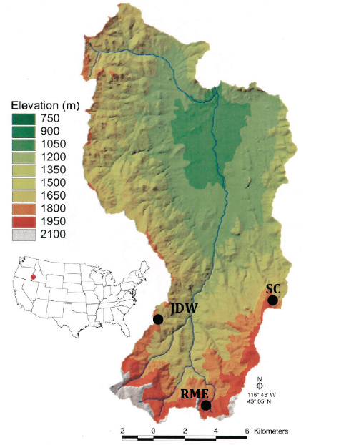

Figure 5.1.1. Aspen stand locations in the Reynolds Creek Experimental Watershed and Critical Zone observatory (RCEW). Johnston Draw (JDW) and Sheep Creek (SC) are warmer, mid-elevation sites, whereas Reynolds Mountain East (RME) is a cooler, high elevation site.

Table 5.1.2. Changes in precipitation, snow residence time, growing season days, and net primary production (NPP) from historical to mid- 21st century conditions. Standard deviations are indicated in parentheses (n= 20 total simulation years at SC and RME, 13 simulation years at JDW). Growing season length is the period of initial leaf flush to complete leaf senescence simulated by Biome-BGC MuSo.

|  |  |  |  |  |  |  |  |
| --- | --- | --- | --- | --- | --- | --- | --- |
| Site | Measured  uniform precip  (mm) | Drift factor | Historical effective precip  (mm) | Mid-century effective  precip (mm) | Snow pack residence (days) | Growing season length  (days) | NPP (g C m-2 yr-1) (% change) |
| Sheep Creek (SC) | 446 (130) | 3.98 | 1030 (412) | 757 (321) | -73 (20) | +13 (6) | -15.3 |
| Reynolds Mountain East (RME) | 962 (188) | 1.45 | 1180 (242) | 1109 (227) | -63 (20) | +14 (8) | +4.5 |
| Johnston Draw (JDW) | 685 (99) | 2.17 | 944 (134) | 810 (99) | -80 (22) | +15 (6) | -11.9 |

Table 5.1.1. Site description and leaf area index (LAI) for Reynolds Mountain East (RME), Johnston Draw (JDW), and Sheep Creek (SC). Standard deviations are indicated in parentheses (n=20 simulation years at SC and RME, 13 simulation years at JDW).

|  |  |  |  |  |
| --- | --- | --- | --- | --- |
| Parameter | RME | JDW | SC | Method |
| Elevation (m) | 2038 | 1782 | 1817 | --- |
| Mean annual air temperature (°C) | 5.3 (0.6) | 7.2 (0.8) | 7.1 (0.7) | Historical mean |
| Observed LAI (m2 m-2) | 0.9 (0.7) | 1.7(1.1) | 1.4 (0.9) | Measured |
| Simulated LAI (m2 m-2) | 1.4 | 1.5 | 1.6 | Historical mean |

5.1.2 *Simulations of snow redistribution*

Across the RCEW, snow drifts vary in size depending on topographical complexity, temperature, and total incoming precipitation. Simulations of snow redistribution from the model iSnobal (Marks et al. 1999) were used to determine increases in snow water equivalent (SWE) held in drifts relative to a uniform precipitation layer. iSnobal is a spatially adapted version of the physically based, energy balance model Snobal that produces grid based simulations of snow states and melt based on climate forcings, vegetation, and topography (Winstral et al. 2013, Reba et al. 2011, Winstral and Marks, 2002). This model has been applied to watersheds of various sizes across the Pacific Northwest and has been used extensively within the RCEW (Winstral et al. 2013, Nayak et al. 2012, Reba et al. 2011, Seyfried et al. 2009, Marks et al. 2001).

For this study, drift factors representing the amount of snow water held in snowdrifts relative to a uniform precipitation layer were used to adjust measured precipitation data. Drift factors were calculated using values of iSnobal-simulated peak SWE from a point located in the center of drifts either lying directly upslope of stands simulated by Biome-BGC and precipitation measured at a neighboring climate station. The annual drift factor (*DF*) was calculated as the ratio of peak SWE simulated by iSnobal to total measured uniform precipitation occurring from the date of initial drift formation to the date of peak SWE simulated by iSnobal (referred to here as the drift accumulation period) using the equation:

$DF=\frac{Peak simulated SWE (mm)}{Total measured uniform snow (mm) across drift accumulation period}$ (1)

Drift factors were then applied to measured frozen precipitation based on 0°C daytime and nighttime temperature thresholds.

5.1.3. *Estimates of Aspen NPP*

Biome-BGC MuSo (short for multi-layer soil module, Hidy et al. 2016), was used to simulate aspen NPP. Like its predecessor Biome-BGC (v 4.2, Thornton et al. 2002), Biome-BGC MuSo is a point-based biogeochemical process model that predicts ecosystem processes and plant productivity through the simulation of daily carbon, nitrogen, water, and energy fluxes.

5.1.4. *Parameterization of BIOME-BGC MuSo*

Biome-BGC MuSo was forced using daily meteorological inputs that were both measured at climate stations neighboring each site and simulated using the point based microclimate model MTCLIM (v. 4.3, Thornton et al. 2000). Complete historical climate data sets spanned 1996-2015 for RME and SC, and from 2003-2015 for JDW. Final simulations of soil storage and LAI were compared to measured site values.

5.1.5 *Climate change projections*

To represent climate change conditions predicted for the mid 21st century, projected temperature increases were applied to historical climate datasets. Downscaled monthly *Tmax* and *Tmin* for both historic (1985-2005) and mid-century conditions (2046-2065) were obtained from a 20-model ensemble mean of CMIP5 global circulation models (Taylor et al. 2012) using the Multivariate Adaptive Constructed Analogs (MACA) downscaling method (Abatzoglou and Brown, 2012). Monthly temperatures were downscaled to 4 km grid cells and based on a continued high CO2 emissions scenario (RCP 8.5). Changes in *Tmax* and *Tmin* at each site were determined by the difference between monthly downscaled historic temperatures and projected monthly mid-century temperatures obtained from the MACA data portal. Average monthly *Tmax* and *Tmin* increases were then applied to measured daily temperatures for the years 1996-2015 at RME and SC and 2003-2015 at JDW. Once temperature increases were applied to daily climate records, precipitation data for climate change simulations were adjusted to account for the redistribution of frozen precipitation under warmer, mid-century conditions. Annual atmospheric CO2 concentrations (ppm) recommended by the coupled model intercomparison project (CMIP5) for RCP 8.5 were used for both historical (1996-2015) and mid-21st century (2046-2065) simulations (Meinshausen et al. 2011).

**5.2 *Post fire aspen regeneration***

5.2 *Post fire aspen regeneration - study area and design*

The study area for this objective encompassed 22 fires that burned between 2000 and 2013 on federally managed land across central Idaho and western Montana (Fig 5.2.1). We used a stratified random sampling design to identify and sample 65 sites using time since fire and location across a winter-dominated to summer-dominated precipitation gradient as the two primary strata. We used this gradient as a guide in site placement because we were interested in the potential effects of precipitation regimes on post-fire aspen regeneration. Within these two strata we used aerial imagery to visually confirm aspen presence both before and after fire and then randomly assigned field sampling points within aspen stands. Each fire contained between 1-7 plots. To minimize violation of sample independence we located plots > 400 m apart.

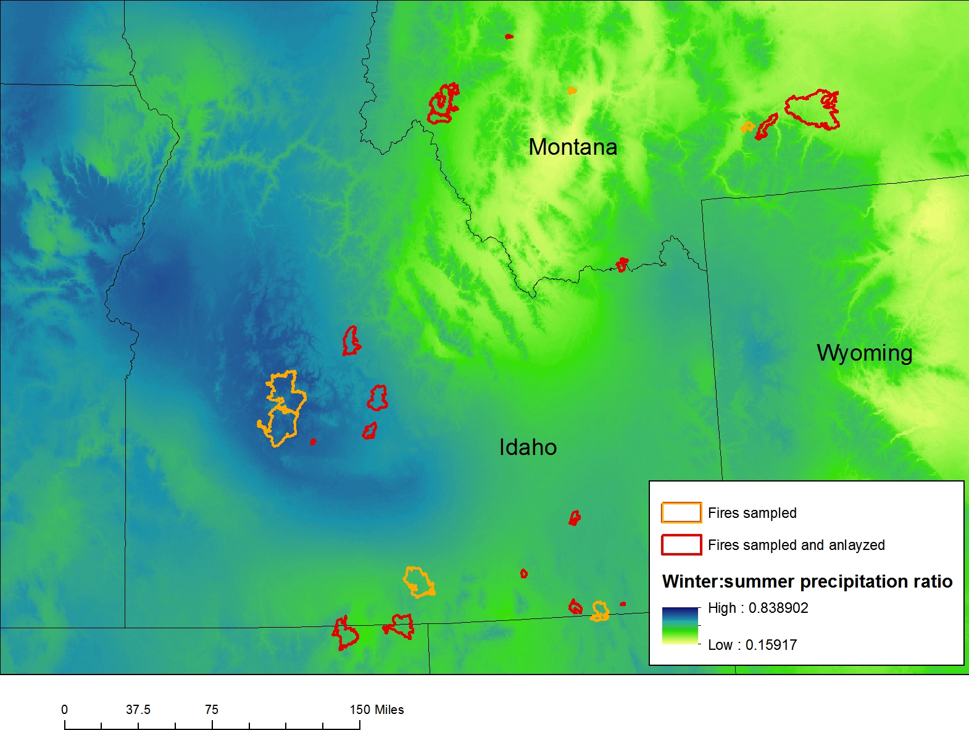

Fig. 5.2.1. Fires sampled and analyzed for Objective 2.

5.2.1 *Post fire aspen regeneration - field and spatial data collection*

Field data were collected during June through August in 2014 and 2015. We used several variables to characterize fire and post-fire conditions for each site. The following data were collected within 50 m transects: sucker/seedling (< 10 cm diameter) density and overstory tree (> 10 cm diameter) density by species, animal browse on suckers and pellet counts, understory vegetation by functional group (e.g. grass, forb), and shrub cover. Elevation and location information were recorded in the field, and slope and aspect for each plot were derived from 30-m digital elevation models (DEMs) following data collection. Time since fire was calculated as the year of sampling minus the fire year. We assessed fire severity in the field by classifying each plot as high (<10% of trees survived the fire) or medium (10-50% of trees survived the fire) severity.

Additional spatial data for fire and climate variables were also obtained for use in our analysis. To investigate the role of fire severity in post-fire regeneration, fire severity and size were obtained from the Monitoring Trends in Burn Severity (MTBS) project (Eidenshink et al. 2007). We calculated the proportion of each MTBS burn severity class (e.g. high, moderate, low, or unburned) within a 100 m buffer surrounding each plot using GIS. For climate variables, we acquired 800-m resolution long-term monthly precipitation and temperature data from the Parameterized-elevation Regression on Independent Slopes Model (PRISM; Daly et al. 2008). We used these data to calculate several climate variables, including climatic water deficit, total annual snow and rain, and a heat load index for each site following Dilts et al. (2015). All variables considered and used in the analysis are in Appendix X.

5.2.2 *Post fire aspen regeneration - data analysis*

Initial data exploration included assessment of several climate variables (Appendix X) that represented various seasonal combinations before and after each fire as well as long-term averages, calculated as the 30 years prior to the most recent fire year (1980-2009). For each climate variable explored, we calculated a ratio of pre- and post-fire values to long-term (30 year) averages so that we could explore climate trends around the time of fire (e.g., van Mantgem et al. 2013, Harvey et al. 2016). For example, the average annual precipitation three years prior to fire was divided by the 30-year annual precipitation value.

All analyses were conducted using R statistical software (R Development Core Team 2015). The response variable, post-fire sucker density, was log transformed due to the large range in observed densities. To confirm a lack of spatial autocorrelation across plots we conducted a Mantel test using plot location and aspen densities, and the test was insignificant. We employed the Random Forest classification method as a first step to distill the large number of variables considered in our analyses. We then used the predictor variables that were identified by Random Forest, as well as others that are recognized in influencing regeneration following fire (e.g. heat load, fire severity, Table 5.2.1). Prior to using multiple linear regression, we calculated Pearson correlation coefficients for all predictor variables, and removed any variables with an r value > 0.65 to avoid multicollinearity. We conducted model selection using the ‘glmulti’ package in R (Calcagno 2013), with the top model selected based on the lowest corrected value of Akaike information Criteria (AICc; Burnham and Anderson 2003). Results from any model within 2 AICcs of the top model are included in our results.



Table 5.2.1.Predictor variables that were identified by Random Forest, as well as others that are recognized in influencing regeneration following fire.

In this report we analyzed data from 56 sites that were located in 16 fires that occurred from 2000-2009 (Fig. 5.2.1, Table 5.2.2). Fire size averaged ~19,620 (± 3,100) ha and ranged from 397-81,339 ha while elevation averaged 1989 m (± 28 m SE), ranging from 1547-2349 m. Plots in fires that burned in 2012 or 2013 were excluded from the analysis for two primary reasons. First, although immediate post-fire regeneration patterns is of interest, the mechanisms that drive densities the first few years following fire are often different than those over a longer timeframe (e.g. Hansen et al. 2016), and we wanted to focus on these long-term trends. We were also particularly interested in post-fire climate variables, and the more recent fires have less climate data to analyze (e.g. we could only include climate data for one year following fire for the 2013 sites). We may include the nine fires in further analyses or examine them separately to explore the differences between immediate post-fire densities and regeneration occurring over a longer timeframe. During data analysis we also removed four plots in older fires that were identified as outliers (e.g. a plot with conifer density higher than aspen density), resulting in a total of 52 sites used in the final analysis.



Table 5.2.2.Characteristics of each of the 16 fires sampled and analyzed in the study region.

5.3 *Interactions among water balance, fire regimes, climate change on patterns of aspen distribution – study area and design*

We evaluated aspen distribution in the Tollgate and Dobson Creek subwatersheds of Reynolds Creek Experimental Watershed (hereon, ‘RCEW’), in southwestern Idaho (Fig. 5.3). These are the two most southerly sub-watersheds of the RCEW, and sit at the highest elevation within the RCEW (1298m - 2244m). They are also the only two sub-watersheds with any significant tree cover. The RCEW study extent is approximately 5500ha.

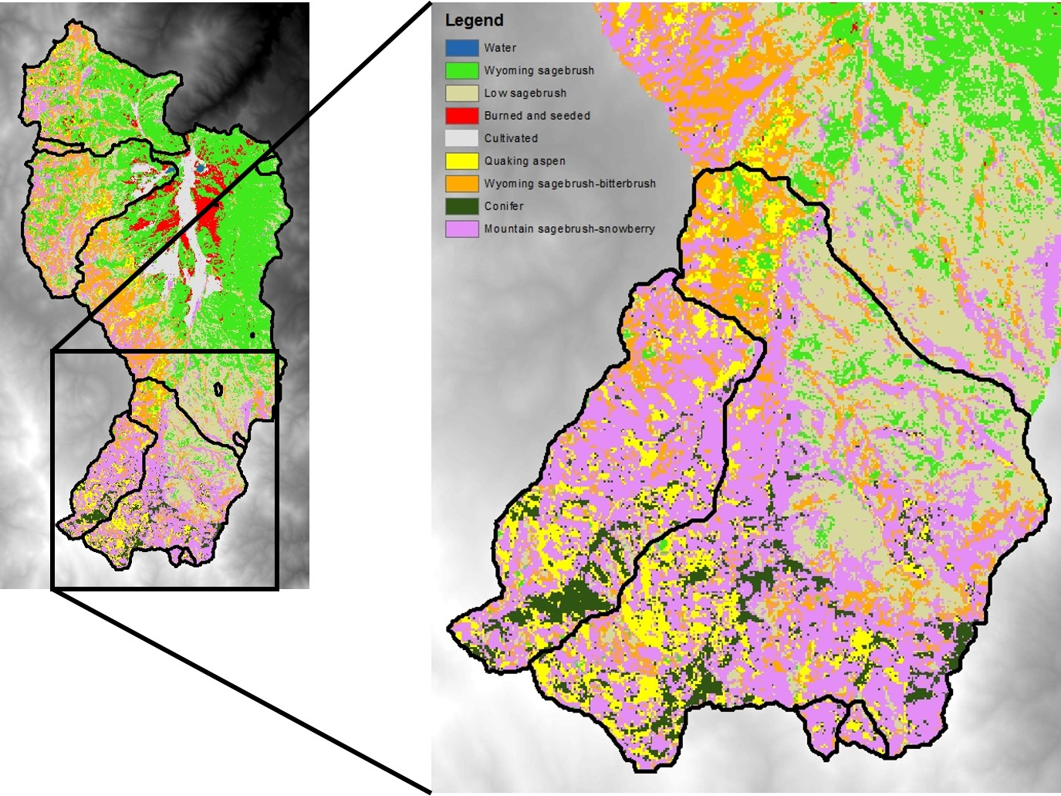

Figure 5.3. Reynolds Creek Experimental Watershed (RCEW) in Southwestern Idaho. Dominant cover types are described. LANDIS-II modeling extent (delineated by sub-watershed) is outlined in black. Cover type data is administered USDA-Agricultural Research Service Northwest Watershed Research Center (ARS NWRC).

We forecast aspen distributions for 83 years using LANDIS-II, a spatially dynamic framework for estimating forest landscape change as a function of establishment, growth, and mortality. Tree species composition is spatially and temporally dynamic and represented as species-age cohorts; each species has unique life history attributes that determine response to disturbance and seed dispersal capacity (Scheller et al. 2007). LANDIS-II has been extensively used to estimate climate change effects in the western US (Loudermilk et al. 2013, 2014, 2016, Creutzburg et al. 2017, Kretchun et al. 2016), including Idaho (Yang et al. 2015). Model inputs are detailed below. The Biomass Succession extension (modified v3.2) was used to model cohort growth and mortality (Scheller and Mladenoff 2004). Biomass Succession tracks aboveground net primary productivity (ANPP; g C/m2/year) as well as aboveground biomass (g C/m2). Updates to cohort mortality functions within Biomass Succession were made to accommodate the unique clonal biology of quaking aspen (described below). We simulated fire using the Base Fire extension (v3.0.3) (He and Mladenoff 1999).

We simulated the potential future distribution and biomass of aspen over time (from 2016 to2099, at 1-year time steps) and space (at 10mx10m cell resolution) under two climate scenarios (described below).

*5.3.1 Forecast aspen distribution - spatial data collection*

*Climate Data*: Downscaled climate data was obtained from the Basin Characterization Model (BCM). BCM calculates water balance (including runoff, recharge, and evapotranspiration), by modeling the interaction between climate and empirically measured biophysical landscape features (Flint et al. 2013). A low (RCP4.5) and high (RCP8.5) emissions scenario were modeled for each chosen GCM to examine the effects of climate change. A suite of GCM climate projections were used because they captured a range of anticipated climatological outcomes and had good hind-casted performance in the West (Fig. 5.3.1).

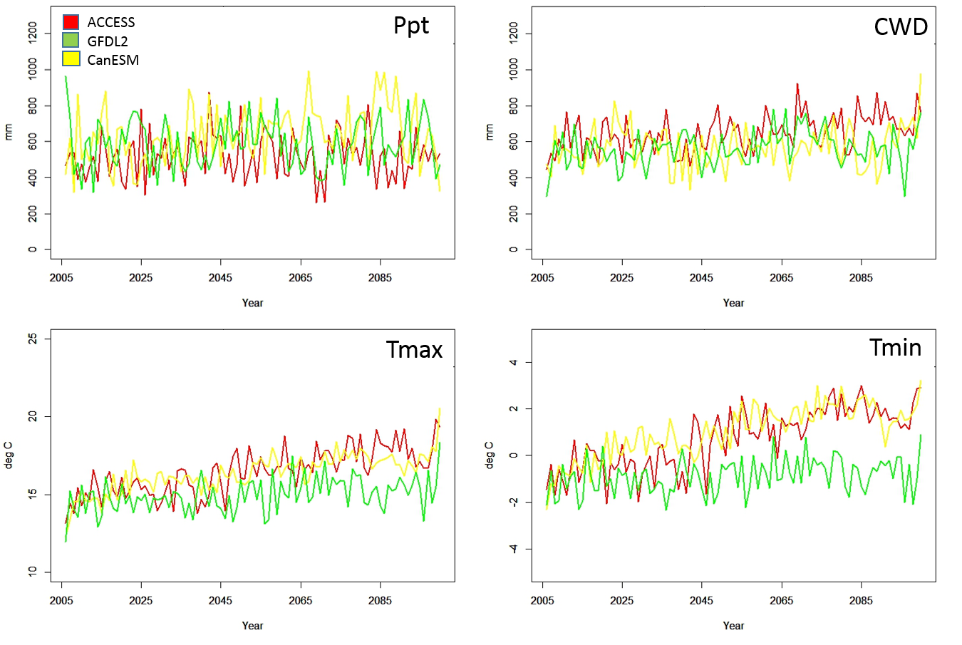

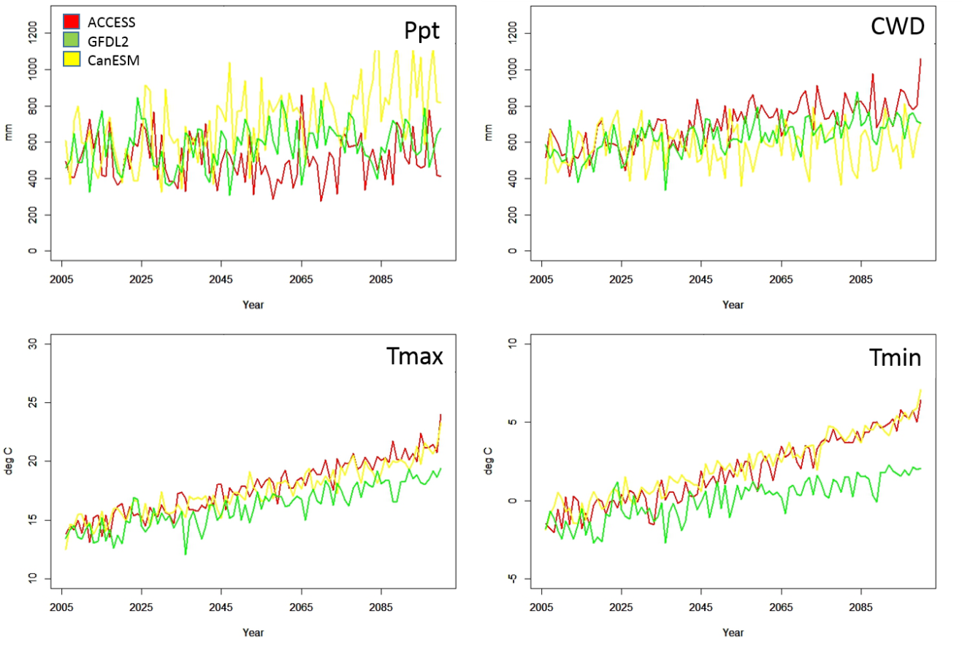

Figure 5.3.1. From left to right, top to bottom: Average annual total precipitation (Ppt), Cumulative annual climate water deficit (CWD), average annual temperature maximum (Tmax) and minimum (Tmin) from the Basin Characterization Model, RCP 4.5 and 8.5 emissions scenarios.

*Initial Communities***:** An initial community was created that defined the spatial distribution and ages of each tree or shrub species present on the landscape. Initial communities were created by sampling US Forest Service FIA subplots from a radius of 50km around RCEW, and randomly assigning those plots to a digitized map of forest types within the RCEW (ARS NWRC*)*. Because of our 10x10m cell size, we used the FIA subplots (14.6m diameter) as our pool of potential initial communities. FIA sampling from around the RCEW resulted in 1894 unique FIA plots, which each contained 4 subplots – a total of 7576 unique subplots. From these subplots, tree species, DBH, age, and biomass were extracted for the following three tree species modeled in this study: Douglas fir (*Pseudotsuga menziesii*), Quaking aspen (*Populus tremuloides*), and Western juniper (*Juniperus occidentalis*). Shrubs are not important competitors to aspen although they provide fuels for fire spread, therefore shrubs were grouped into a generic shrub type rather than represented as individual species.

*Ecoregions:*Ecoregions representing homogeneous soils and climate were spatially delineated and assigned unique establishment probabilities and mortality rates for each species, and varied through time. The RCEW landscape was divided into ecoregions that captured areas with similar soils, climate, and snowbank accumulation. Ecoregions were delineated using an approach developed by Yang et al. (2015), based on elevation and climatic water deficit (CWD). Four CWD bins were created (using a Jenks natural breaks algorithm) and combined with three equivalent elevation bands to create twelve unique ecoregions. A thirteenth ecoregion was created to represent snowbank accumulation, an ecologically meaningful feature of the RCEW. Snowbanks accumulation location and extent were geographically estimated using ISNOBAL (Winstral et al 2013), a mass and energy balance distributed model which can estimate precipitation redistribution and accumulation.

*Maximum ANPP:* Within the Biomass Succession extension, maximum ANPP (maxANPP) and maximum Biomass (maxB) are species-specific parameters. For this study, maximum annual aboveground net primary productivity (ANPP, g C m-2 yr-1) was simulated using the biogeochemical process model Biome-BGC (v. 4.2, Thornton et al. 2002). Biome-BGC simulates ecosystem processes for a single plant functional type (PFT) through daily fluxes of carbon, nitrogen, water, and radiation. Maximum ANPP for our three tree species, was simulated for each of the 13 ecoregions. For each ecoregion, Biome-BGC was run using daily climate, and further parameterized using site conditions, including soil depth and texture parameters that were obtained from the Soil Survey Geographic Database (SSURGO). Following Biome-BGC simulations, annual ANPP for each species was calculated from daily sums of carbon accumulated and stored in vegetation foliage and stem pools (See section 5.1) .

*Probabilities of Establishment and Mortality:* Within the Biomass Succession extension, probability of establishment (Pest) defines how likely a species is to successfully establish given the climate and soil conditions delineated by ecoregion and can change for each time step. We used non-parametric multiplicative regression (NPMR, McCune 2006) to develop climate niche models and defined Pest for each species. The NPMR models for each species were developed using known presence and absence locations of each species as the response variable, and monthly climate variables as predictor variables (Table X). The final NPMR climate niche models were then used with contemporary and future GCM climate inputs to predict species occurrence probabilities for each cell in the model under different climate scenarios. These probability estimates were then spatially-averaged for each of the 13 ecoregions, and utilized ass Pest values within LANDIS-II.

The probability of mortality ()For aspen, we implemented a simple threshold approach for inducing cohort mortality, which was used to simulate both partial clone (i.e. aboveground stem) mortality and full clone mortality. This approach assumed that aboveground stem aspen mortality does not necessarily lead to clone mortality, but if conditions that cause stem mortality persist, clone mortality will eventually occur. We created a threshold based on Anderegg et al. (2015), who modeled a climatic water deficit (CWD) threshold for aspen mortality linked to moisture deficit-related xylem cavitation. This hydraulic threshold predicted regional patterns of tree mortality with 75% accuracy in both field plots and mortality maps derived from Landsat imagery (Anderegg et al. 2015). We used an annual cumulative threshold of 700 mm CWD and added a probability of mortality (Pmort) to the Biomass Succession extension, whereby there was a 30% probability of aboveground mortality if the threshold was exceeded (Anderegg et al. 2015). When this threshold is exceeded, climate-related mortality events occur and, aspen biomass is reduced by 50% (Anderegg et al. 2015). If a site experienced climate-induced mortality, this approximated aboveground stem (i.e., cohort) mortality. If all neighboring (adjacent) aspen cohorts died, then the larger, multi-cell clone effectively died (e.g., was incapable of resprouting or spreading) until the area was re-colonized via seeding. During dry years, Pmort was higher and Pest was lower, which also reduced regeneration potential through seed-dispersal and establishment.

*5.3.2 Forecast aspen distribution - data analysis*

For each of our scenarios, we examined aspen biomass and area occupied over time. This captures the potential for future temporal and spatial variability of aspen on the landscape in response to climate change.

**5.4 *Hydrological Implications of Climate Change and Aspen Mortality***

5.4.1 *Study site and approach*

We assessed the sensitivity to climate change of snow drifts that subsidize aspen stands in arid rangelands of the Pacific Northwest. As a case study site, we selected Upper Sheep Creek (USC), a small (0.26 km2) headwaters catchment within the Reynolds Creek Experimental Watershed in southwest Idaho. USC semi-arid rangeland watershed with 30 years of hourly meteorological data and a previously calibrated and validated mechanistic hydrological model. In previous studies (e.g. Flerchinger et al. 1998, Flerchinger and Cooley 2000, Chauvin et al. 2011) and in the current study, USC has been divided into three hydrologic response units, comprised of a drift-subsidized aspen stand, an HRU inhabited by big mountain sage in lower northeast-facing slopes, and an HRU composed of low sage, primarily on southwest-facing slopes. The Simultaneous Heat and Water (SHAW) model was applied to test the sensitivity of hydrologic flux dynamics to altered climate conditions. SHAW is a one-dimensional model that simulates energy balance and water fluxes in multi-species canopies, described in Flerchinger et al. 1998 and Flerchinger et al. 2012. SHAW has been applied to Upper Sheep Creek in numerous previous studies, including Flerchinger et al. (1996, 1998, 2012, and 2016), Chauvin et al. 2011, and Flerchinger and Seyfried, 2014. For this research, the version and parameterization of the model that was used was further improved to accurately simulate the hydrological dynamics in aspen canopies (Flerchinger et al. 2015) and accurately discriminate rain from snow based on surface air temperature (Harpold et al. 2017).

5.4.2 *Climate scenarios*

Global climate model (GCM) daily minimum temperature, maximum temperature, and precipitation were obtained from the Integrated Scenarios project, which uses CMIP5 model runs and a multivariate adaptive constructed analogue (MACA) downscaling technique (Abatzoglou et al. 2012, Rupp et al. 2013). For a historical period (1950-2005) and future period (2050-2099) under the representative concentration pathway (RCP) 8.5 for each GCM, average daily temperatures and precipitation were obtained. Differences in mean daily temperature and precipitation between these two time periods were calculated. Differences were identified on both a seasonally variable and constant basis. In the seasonally variable case, changes in temperature and precipitation varied based on the day of year, while in the seasonally constant case, temperature and precipitation changes were applied consistently across each water year. To develop multiple scenarios, temperature and precipitation were each adjusted in constant increments to capture the standard deviation of projected variability (Fig. 5.4.1).

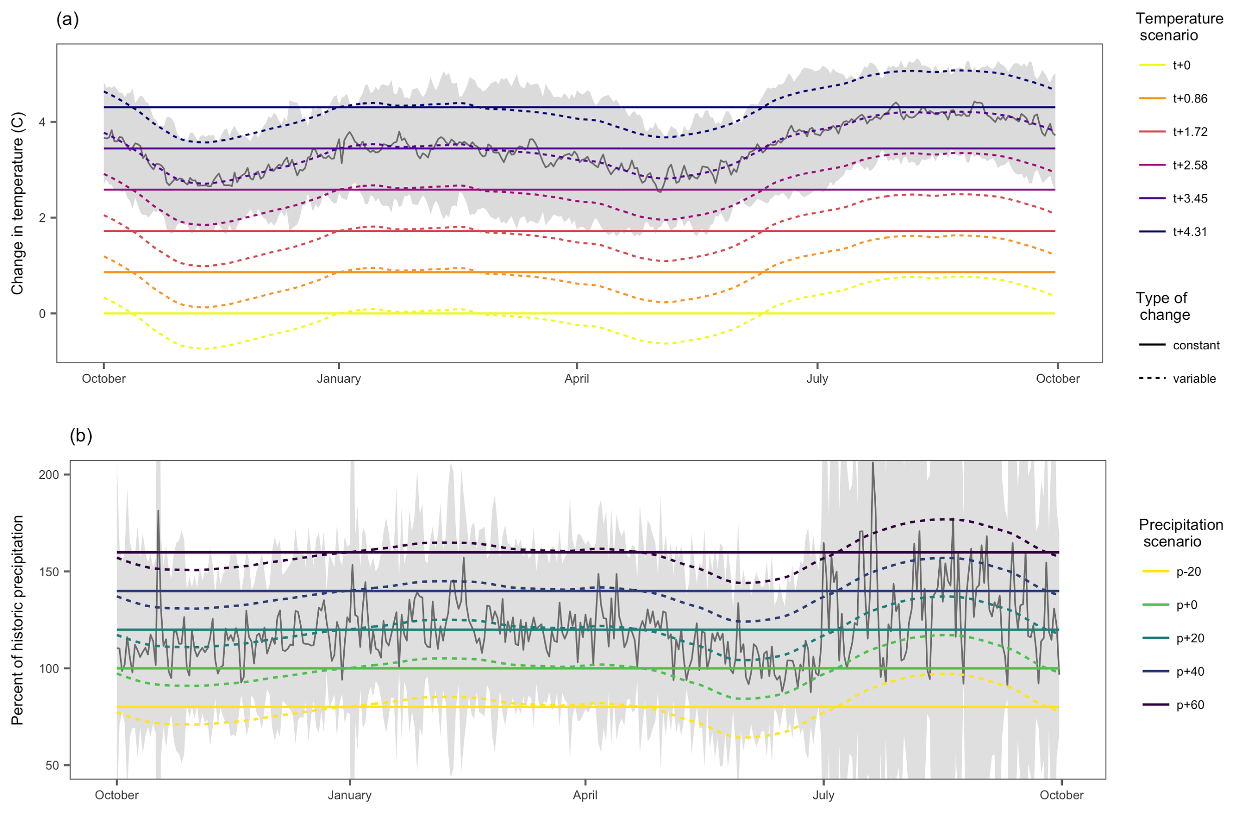

Figure 5.4.1. Seasonally constant and variable changes in temperature and precipitation. The gray lines represent delta functions before loess smoothing, and gray shaded areas represent standard deviations across models. The large standard deviations in summer months are due to low precipitation volumes.

To account for wind-driven snow drifting, empirically derived drift factors were applied to each HRU as described in Chauvin et al. 2011. These drift factors are 2.29, 0.98, and 0.93 for aspen, big, and low sagebrush, respectively.

5.4.3 *Species mortality scenarios*

One objective of this project was to determine the effects of potential aspen mortality on hydrologic fluxes. The SHAW model was run with climate scenarios described above, with aspen vegetation replaced with a low grass cover. To assess the effects of aspen mortality on water availability, both unit and area-weighted average flows were computed for the watershed. Because SHAW is a one-dimensional model, flow is calculated as the sum of surface runoff (which is typically zero), and deep percolation beyond the rooting zone.

5.4.4. *Data analysis*

For each climate scenario and HRU, daily values and annual summary statistics were extracted. Summary statistics included the annual sums of hydrologic states and fluxes (precipitation, evaporation, transpiration, change in soil water content, and deep percolation plus runoff), center of timing (CT) of each of these fluxes (the day of water year at which half of a given flux has occurred for that water year, as described in *Stewart et al. 2005*), and several metrics to describe snowpack dynamics. These snowpack metrics included maximum snow water equivalent (SWEmax),  day of SWEmax (DOMS), and SWE residence time (SWETres), as described in Luce et al. 2014.

Interannual variability of responses to climate change was assessed through analysis of climate trajectories in Budyko space (Budyko, 1974). In this framework, actual evapotranspiration (AET) divided by water availability (typically precipitation) is plotted against potential evapotranspiration (PET) divided by the same water availability. To more accurately describe water availability, we subtracted change in storage (S) from P, as described in Chen et al. 2013. In this Budyko space, vertical displacement indicates water availability for runoff, while horizontal displacement indicates energy versus water limitation. This framework allows for the identification of mechanistic regime shifts, and variability in these regime shifts between years.

**6. PROJECT RESULTS**

**6.1 *Aspen Productivity in a Changing Climate***

*6.1.1 Historical redistribution of precipitation*

After applying drift factors to measured precipitation data, annual effective precipitation was dramatically increased at SC whereas precipitation increases were more modest at JDW and RME where drifts (and associated drift factors) above each stand were smaller (Table 5.1.2). The magnitude of precipitation changes also varied from year to year at each site, indicating annual variability in the dominant precipitation phase and timing of events. Timing of final snowmelt simulated by Biome-BGC and iSnobal varied, however simulations of final melt predicted by Biome-BGC weren’t biased in over or under-prediction of snow melt compared to iSnobal at any site (Fig. 6.1.1).

../../Documents/Graduate%20Research/dissertation%20papers/aspen_manuscript/figure_scripts/melt_time.pdf

Figure 6.1.1. Last day of snowpack presence simulated by both Biome-BGC and ISNOBAL. Distribution along the 1:1 line indicates variation between the two models. Sheep Creek (SC) and Johnston Draw (JDW) are mid-elevations sites. Reynolds Mountain East (RME) is the highest elevation site.

6.1.2 *Soil moisture storage*

From approximately March through October, measured and simulated soil moisture storage followed similar trends (Fig. 6.1.2). However, during the fall and winter following aspen leaf senescence, simulated soil recharge occurred more rapidly than measured recharge. Despite divergence between simulations and observations during the fall and winter, periods of soil moisture critical to aspen productivity (spring and summer) use were reasonably represented by Biome-BGC MuSo.

../../Documents/Graduate%20Research/dissertation%20papers/aspen_CC_manuscript/aspen_CC_MuSo_ch2/tables_figures/storage_vwc/muso_storage.pdf

Figure 6.1.2. Measured and Biome-BGC MuSo simulated soil storage in the top meter of soil during 2014-2015 at Sheep Creek (SC), Reynolds Mountain East (RME), and Johnston Draw (JDW). Probe failure prevented storage calculations at JDW from July 2015 to January 2016.

6.1.3 *Climate change impacts on temperature and precipitation*

Average downscaled monthly temperatures projected for the mid-21st century (2046-2065, RCP 8.5) were 3.2 (SD= 0.4) degrees warmer than historical (1985-2005) downscaled temperatures (Figure 6.1.3). Variable drift factors at each site led to differences in historical effective precipitation where, despite being a drier site, effective precipitation held in the drift below SC is similar to the that of RME, a cool site located below a smaller drift (Figure 6.1.4 a,b, Table 2). Historically, JDW is the warmest site and is located under a relatively small drift, resulting in a drift containing approximately 50% of the snow water simulated at RME and SC. Under mid-century conditions, both snow residence time and average SWE held in snow drifts was significantly reduced at all sites (Table 5.1.2, Figure 6.1.4).

aspen_CC_manuscript/tables_figures/maca_temp.pdf

Figure 6.1.3. Average monthly temperature increases (error bars denote one standard deviation, n=20) from historic (1985-2005) and mid-century (2046-2065) projections obtained from 20 GCMs used in the Multivariate Adaptive Constructed Analog (MACA) downscaling method. Average monthly temperature increases were applied to measured *Tmax* and *Tmin* at each site to create warming scenarios representative of mid-century conditions.

Figures/monthly_snow.pdf

Figure 6.1.4. Average monthly redistributed snow water held in drifts at Sheep Creek (SC), Reynolds Mountain east (RME), and Johnston Draw (JDW). Error bars indicate standard deviations (n= 20 simulation years at SC and RME, n= 13 simulation years at JDW).

6.1.4 *Climate change impacts on Mid-21st century NPP*

At warmer, mid-elevation sites, average annual NPP rates across simulation treatments decreased under mid-century conditions (15% and 12% at SC and JDW respectively, Figure 6.1.5, Table 5.1.2). However, compared to JDW, where NPP was consistently lower by mid-century, the response of NPP to warming at SC showed more variability. At SC, mid-century NPP rates could either match those under historical conditions or be decreased by over 25% for certain years (e.g., 2015/2065, Figure 6.1.6). Unlike the warmer and drier mid-elevation sites, RME showed the opposite response, where mid-century NPP tended to remain at or increase from historic levels for most simulation years (average of 4.5 % increase across simulation period, Figure 6.1.5, Table 5.1.2).

npp_ann.pdf

Figure 6.1.5. Annual net primary productivity (NPP) of Sheep Creek (SC), Reynolds Mountain East (RME), and Johnston Draw (JDW) simulated under historical and warmer mid-21st century conditions.

Under mid-21st century conditions, warmer temperatures led to earlier spring leaf flush and increased spring NPP. However, increased vapor pressure deficits later in the summer led to significant reductions in NPP for the remainder of the growing season. For example, 2015 was one of the most productive years under historical conditions (Figure 6.1.5) even though mid-elevation sites (SC and JDW) experienced a low snowpack followed by a growing season where average daytime VPD could exceed 3.0 kPa (Figure 6.1.6). Following mid-century temperature increases, snowpack was significantly reduced at all sites and aspen leaf flush (indicated by the onset of positive NPP rates) occurred over two weeks earlier than historical conditions (Table 5.1.2). By mid-July (~day of year 170), increased evaporative demand led to rapid reductions in stomatal conductance and NPP that persisted across the remainder of the growing season (Figure 6.1.6). In total, annual NPP at SC during 2015 was reduced by 27% under mid-21st century conditions indicating that warmer spring temperatures coupled with increased spring growth are not always sufficient to compensate for drought induced reductions in productivity that occur later in the growing season. Unlike mid-elevation sites, the cooler, high elevation site RME experienced large increases in spring NPP under mid-21st century conditions resulting in a net increase in annual NPP under mid-21st century conditions (Figures 6.1.5, 6.1.6).

daily_2015.pdf

Figure 6.1.6. Daily simulations of snow water, average daytime vapor pressure deficit (VPD), and net primary production (NPP) for Sheep Creek (SC), Reynolds Mountain east (RME), and Johnston Draw (JDW) during 2015 and its associated mid-century year 2065. Blue lines represent historic conditions, while red lines represent warmer, mid-century conditions. Dates of spring leaf flush are indicated by the onset of positive NPP rates.

6.2 *Post fire aspen regeneration*

Post-fire aspen densities ranged from 2,500-49,200 trees per ha, with a mean aspen density of 17,800 (± 1,490 SE) trees per ha across plots. Conifers were largely absent across the study area, with the exception of seven sites in Montana that had conifer densities ranging from 50-800 seedlings per ha. The most commonly encountered conifers were *Abies lasiocarpa* and *Pseudotsuga menziesii*, but a few plots also had *Pinus contorta* and *Picea engelmannii*. Shrub cover ranged greatly across plots from 0-82%, with a mean of 30% (± 4% SE). Common shrubs found across the study area include *Symphoricarpos oreophilus*, *Prunus virginiana*, *Ceanothus velutinus* and *Rosa woodsii*.

Multiple linear regression examining post-fire aspen densities produced five models within 2 AICc of a top model, with both climate and site-specific variables included in the final models (Table 6.2). The top model showed that winter temperatures before fire and the annual timing of precipitation following fire influenced sucker densities, as did fire severity, heat load index, and shrub cover. We found a negative relationship between aspen density and the ratio of winter minimum temperature three years before fire to the long-term average, indicating that colder than average winter temperatures were correlated with lower aspen densities. The precipitation variable included in the final model was calculated as growing season precipitation (April-September) three years after fire divided by mean annual precipitation. Therefore, a higher precipitation ratio indicates more precipitation occurred during the growing season whereas a lower ratio indicates more precipitation during winter and early spring. There was a negative correlation between aspen density and the precipitation ratio, suggesting that as the precipitation ratio increases (more growing season precipitation), aspen densities decline. A positive relationship with heat load index, which incorporates the topographic effects on solar radiation and potential evapotranspiration, indicates that aspen regeneration following fire was higher on warmer and drier slopes. There was a negative relationship with shrub cover, suggesting interspecific competition depresses aspen densities. Additional variables that were included in the five best models, but that were not identified as significant terms, included browsed leader and fire size (negative relationships with aspen sucker density).



Table 6.2. Linear regression results for top models (∆AICc < 2) predicting log transformed aspen sucker (< 10 cm diameter) densities in fires that burned from 2000-2009.

6.3 *Forecast aspen distribution*

The probability of establishment declined for all three modeled tree species while the probability of mortality for aspen generally increased under both low emissions (RCP 4.5) and high emissions (RCP 8.5; Fig. 6.3.1). Probabilities of establishment are highly variable in all ecoregions, but correlated across the landscape. The increases in probability of mortality were most severe in the latter half of the projected century, with >0 values occurring most years in the high emissions (RCP8.5) climate scenario. In general, probabilities of mortality were consistently highest amongst low elevation ecoregions where climatic water deficit often exceeded our defined threshold.

The area occupied by aspen increased modestly under low emissions and declined under high emissions (Fig 6.3.2). There was a pronounced increase in aspen aboveground biomass in both climate scenarios before 2050, though this trend reversed in the high emissions scenario. The area occupied by Douglas fir increased under both climate scenarios although the effect was more pronounced under the more moderate RCP4.5 scenario.

With regards to the ‘snowbank’ ecoregion, probabilities of mortality were often, but not always, the lowest among our thirteen ecoregions (Fig. 6.3.1). Similarly, probabilities of establishment were often, but not always, the highest among our thirteen ecoregions. Related to these trends, aspen persisted longest on sites within or very near our designated snowbanks, particularly in the mid-elevation central-eastern area of the study extent (Figs 6.3.2 and 6.3.3). This effect was somewhat climate-specific however, with reduced biomass even on long-term occupied sites under high emissions climate (Fig 6.3.4). In higher elevation snowbank-adjacent sites, Douglas-fir biomass generally increased.

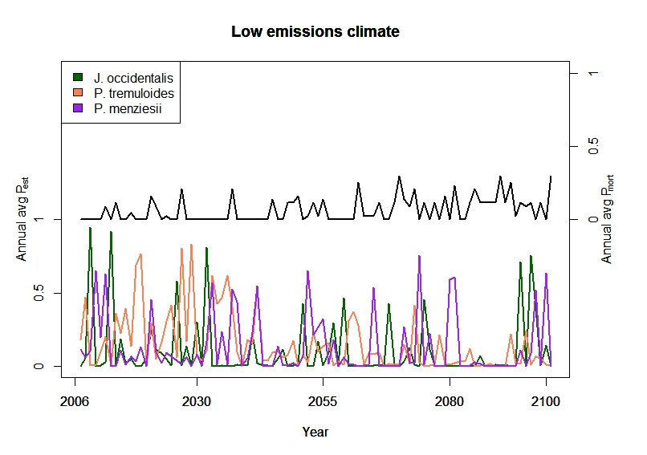

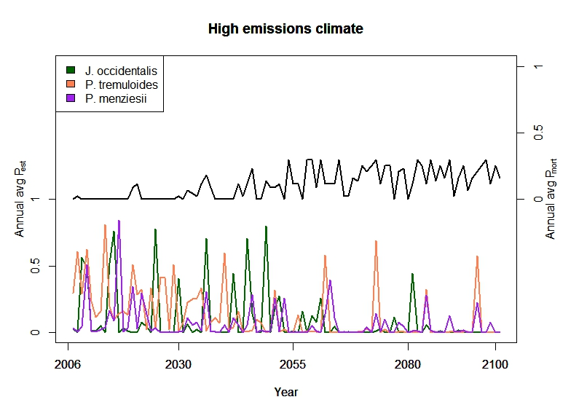

Fig. 6.3.1. The landscape average probability of establishment declined for all three tree species while the probability of mortality generally increased for aspen (black lines) only under both low (RCP 4.5) and high emissions (RCP 8.5).

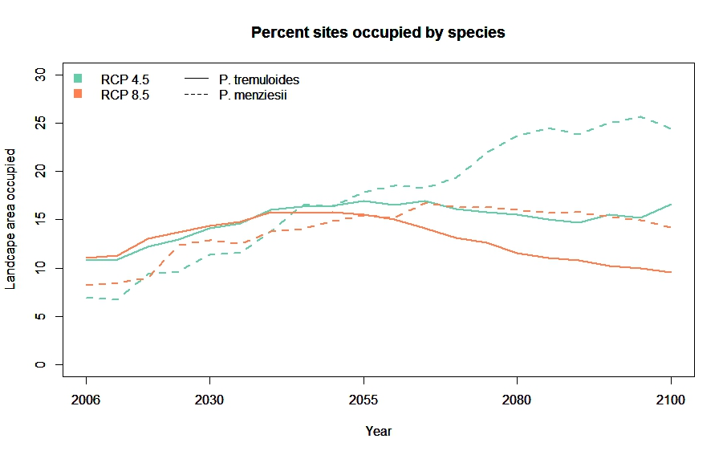

Figure 6.3.2. Area occupied by aspen (solid lines) and Douglas-fir (dashed lines) under low emissions (green) and high emissions (pink) climate.

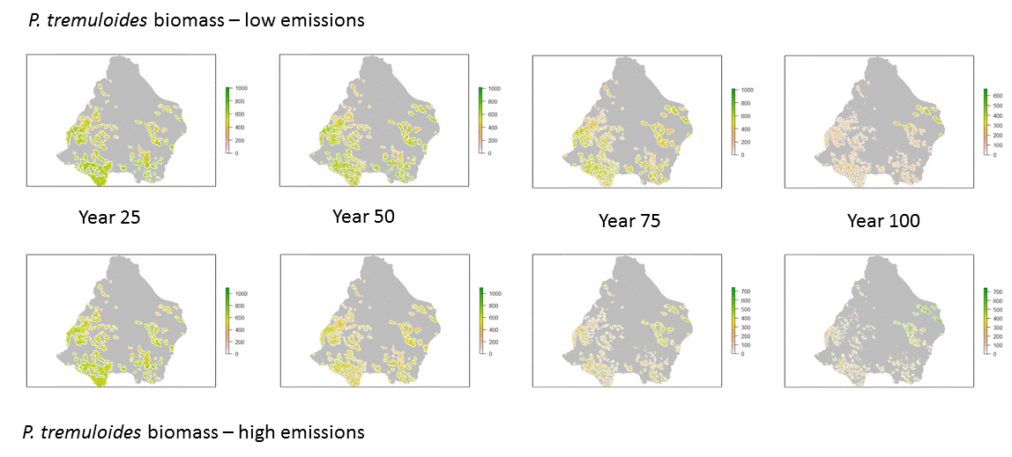

**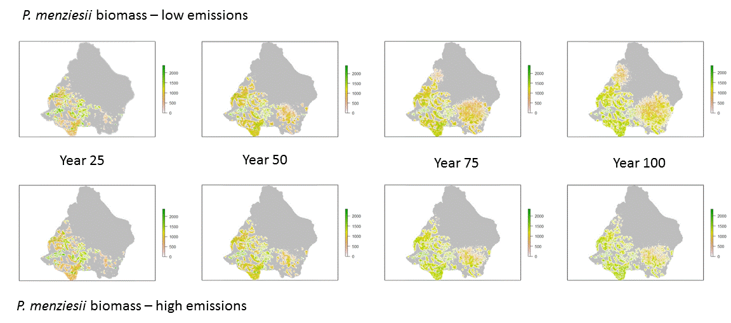**

Figure 6.3.3. Spatial distribution and changes in lasbiomass

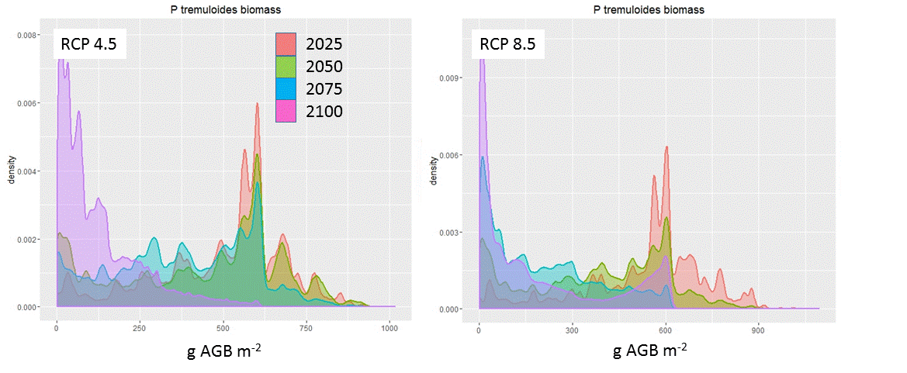

Figure 6.3.4. d, as represented by the density of cells with a particular aboveground biomass., but both climate scenarios showed similar patterns.

**6.4 *Hydrological Dynamics***

6.4.1 *Temperature Effects*

Interannual mean hydrologic effects of temperature change are summarized in Fig. 6.4.1(a). In the aspen HRU, under the T+3.45 scenario with seasonally constant change, drift-corrected precipitation was reduced by 21.1%, due to the reduction in the drift subsidy. In this scenario, SWEmax was reduced by 65.6% compared with the historic scenario. Timing metrics of SWE also changed; DOMS advanced by 40 days, while SWETres was reduced from 80 to 33 days. Evaporation increased by 28.4%, whereas the transpiration change was negligible. Total runoff decreased by 70.8%.

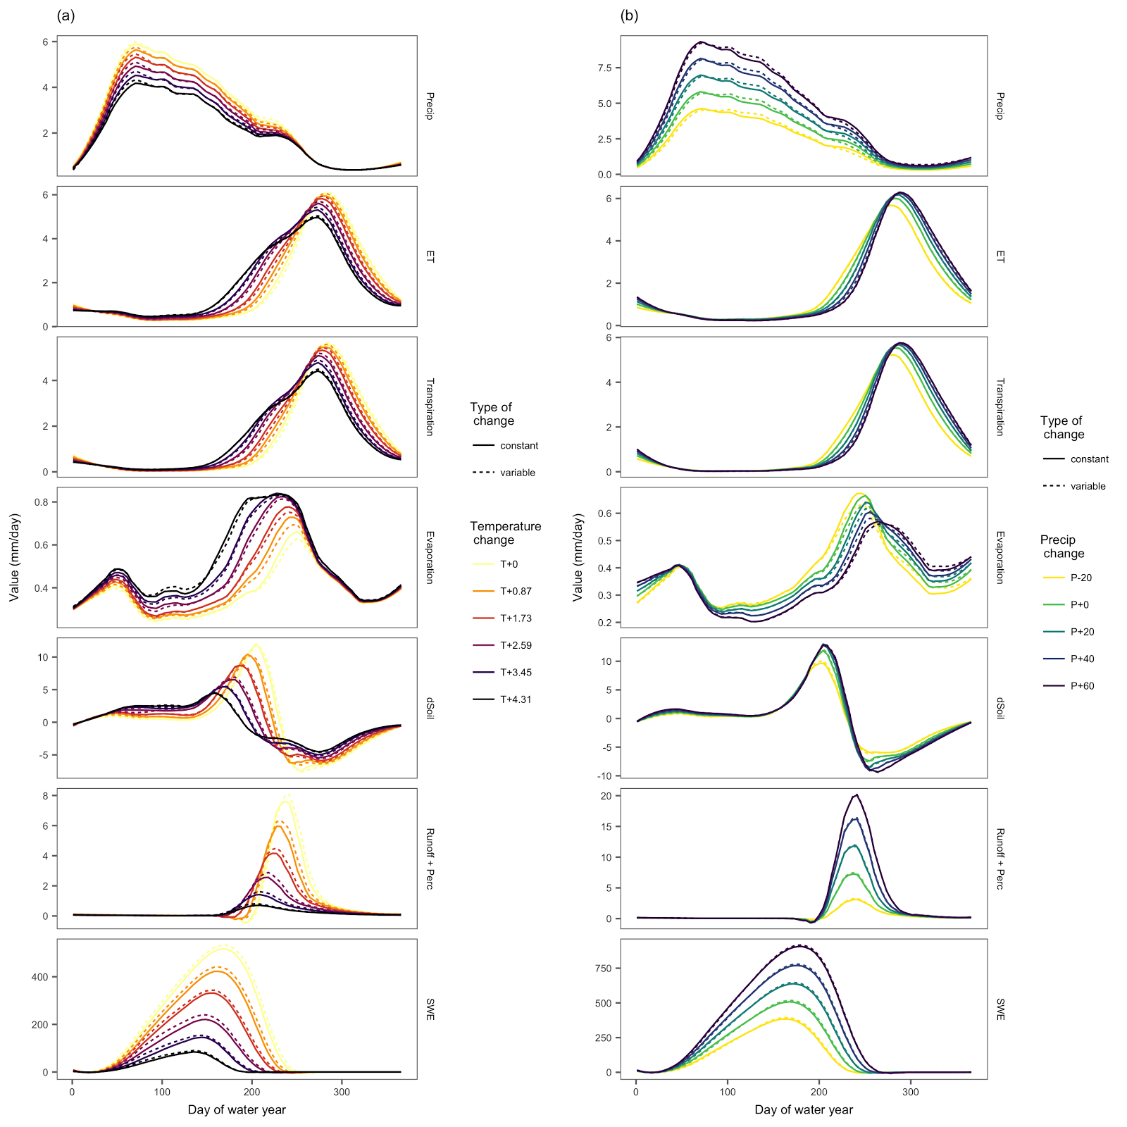

Figure 6.4.1. Effects of (a) temperature and (b) precipitation changes on hydrologic fluxes and SWE in drift-subsidized aspen stands. Each curve is a locally weighted regression with Gaussian weighting, representing a smoothed value of 30 years of data, with smoothing span set to 3 months.

Results were very similar for the seasonally variable case, though hydrologic effects were slightly mitigated by the seasonal variability. When temperature was changed in a seasonally variable way, drift-corrected precipitation was reduced by only 19.8%. SWEmax was reduced by 63.8%, rather than 65.6%. In this seasonally variable case, SWETres was 35, rather than 33 days, and DOMS moved by 40, rather than 41 days.  
  
6.4.2 *Precipitation Effects* Hydrologic effects of precipitation change are summarized in Fig. 6.4.1(b). Under seasonally constant precipitation increase of 20%, SWEmax increased by 22.2%. DOMS occurred 4 days later, while SWETres increased by 5 days. The effects of this amount of precipitation change on evaporation and transpiration were negligible, and flow increased by 5%. The effects of seasonally variable changes in precipitation were very similar to those of seasonally constant changes; the only variable assessed with significant change was the sum of change in soil moisture over the water year, which was 14% greater in the seasonally variable change case.

6.4.3 *Combined temperature and precipitation*

In the case where temperature increased by 3.45 °C and precipitation increased by 20%, effective precipitation decreased by only 4.7%, suggesting that this combination of temperature and precipitation increase, along with drift adjustments, resulted in very little change in precipitation. Evaporation increased by 30.3%, while transpiration increased by 7.3% and flow decreased by 35.7%, suggesting increased partitioning to ET and less to flow. SWEmax was reduced by 54.4% compared to the historical scenario, suggesting that the increase in precipitation partially offset the reduction in SWEmax, even at this relatively large increase in temperature. The sensitivity of hydrologic response variables to altered temperature and precipitation was generally not altered by the seasonal variability of temperature and precipitation changes (Fig. 6.4.2).

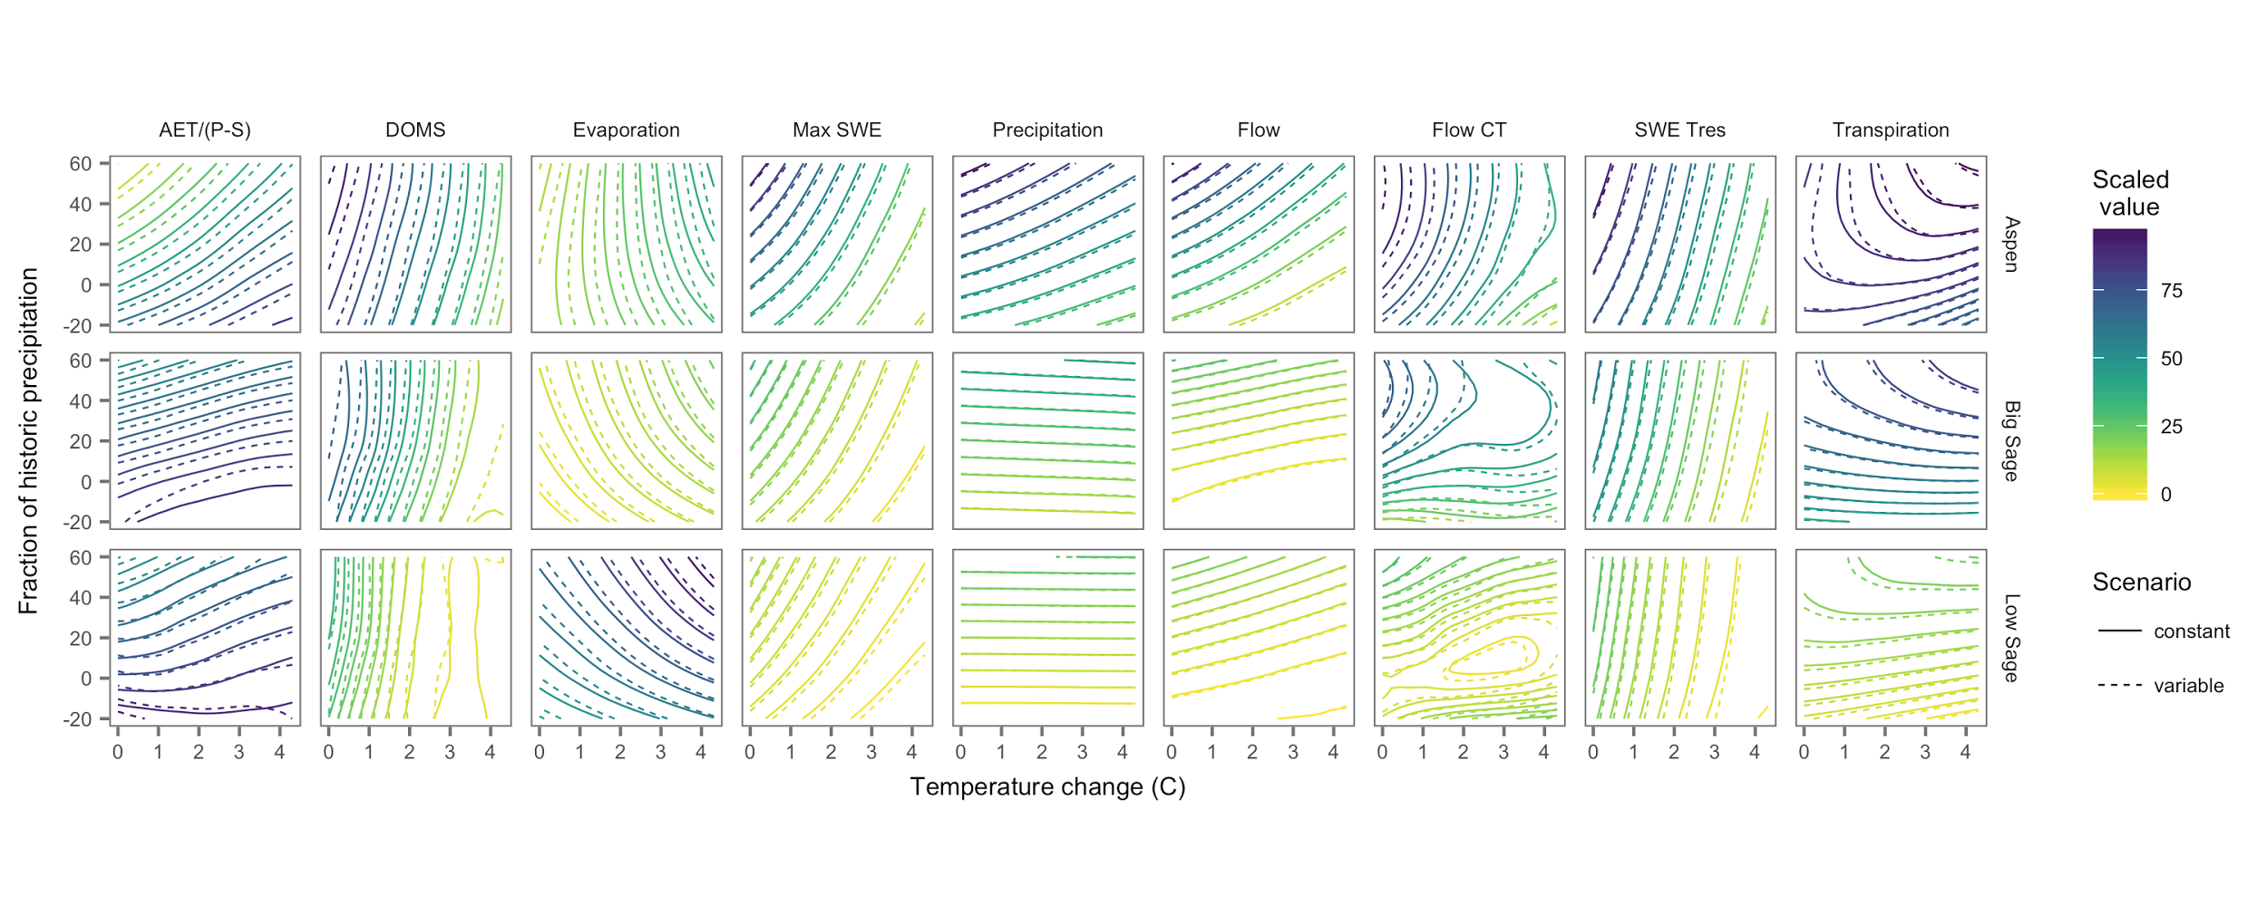Figure 6.4.2. Response of hydrological variables to combined changes in temperature and precipitation in both seasonally constant and variable manner.

6.4.4 *Aspen mortality effects*

In scenarios where aspen died and was replaced with grass, combined effects of changing climate and mortality depended strongly on whether precipitation increased or decreased (Fig. 6.4.3). In scenarios in which temperature and precipitation both increased, mortality exacerbated the effects of climate change on flow, moving runoff timing earlier in the water year. When temperature increased by 3.45 °C and precipitation increased by 20%, CT of flow from the aspen HRU advanced by 38 days in the scenario with mortality, in contrast to a mean 28 day advance in the scenario without mortality.  With the same temperature increase but no change in precipitation, runoff from the aspen HRU decreased by a mean of 293 mm/year without mortality, but only decreased by 93 mm/year in the case with mortality. Changes in flow in each HRU, as well as area-weighted averages across the watershed for each climate scenario are in Table 6.4.1.

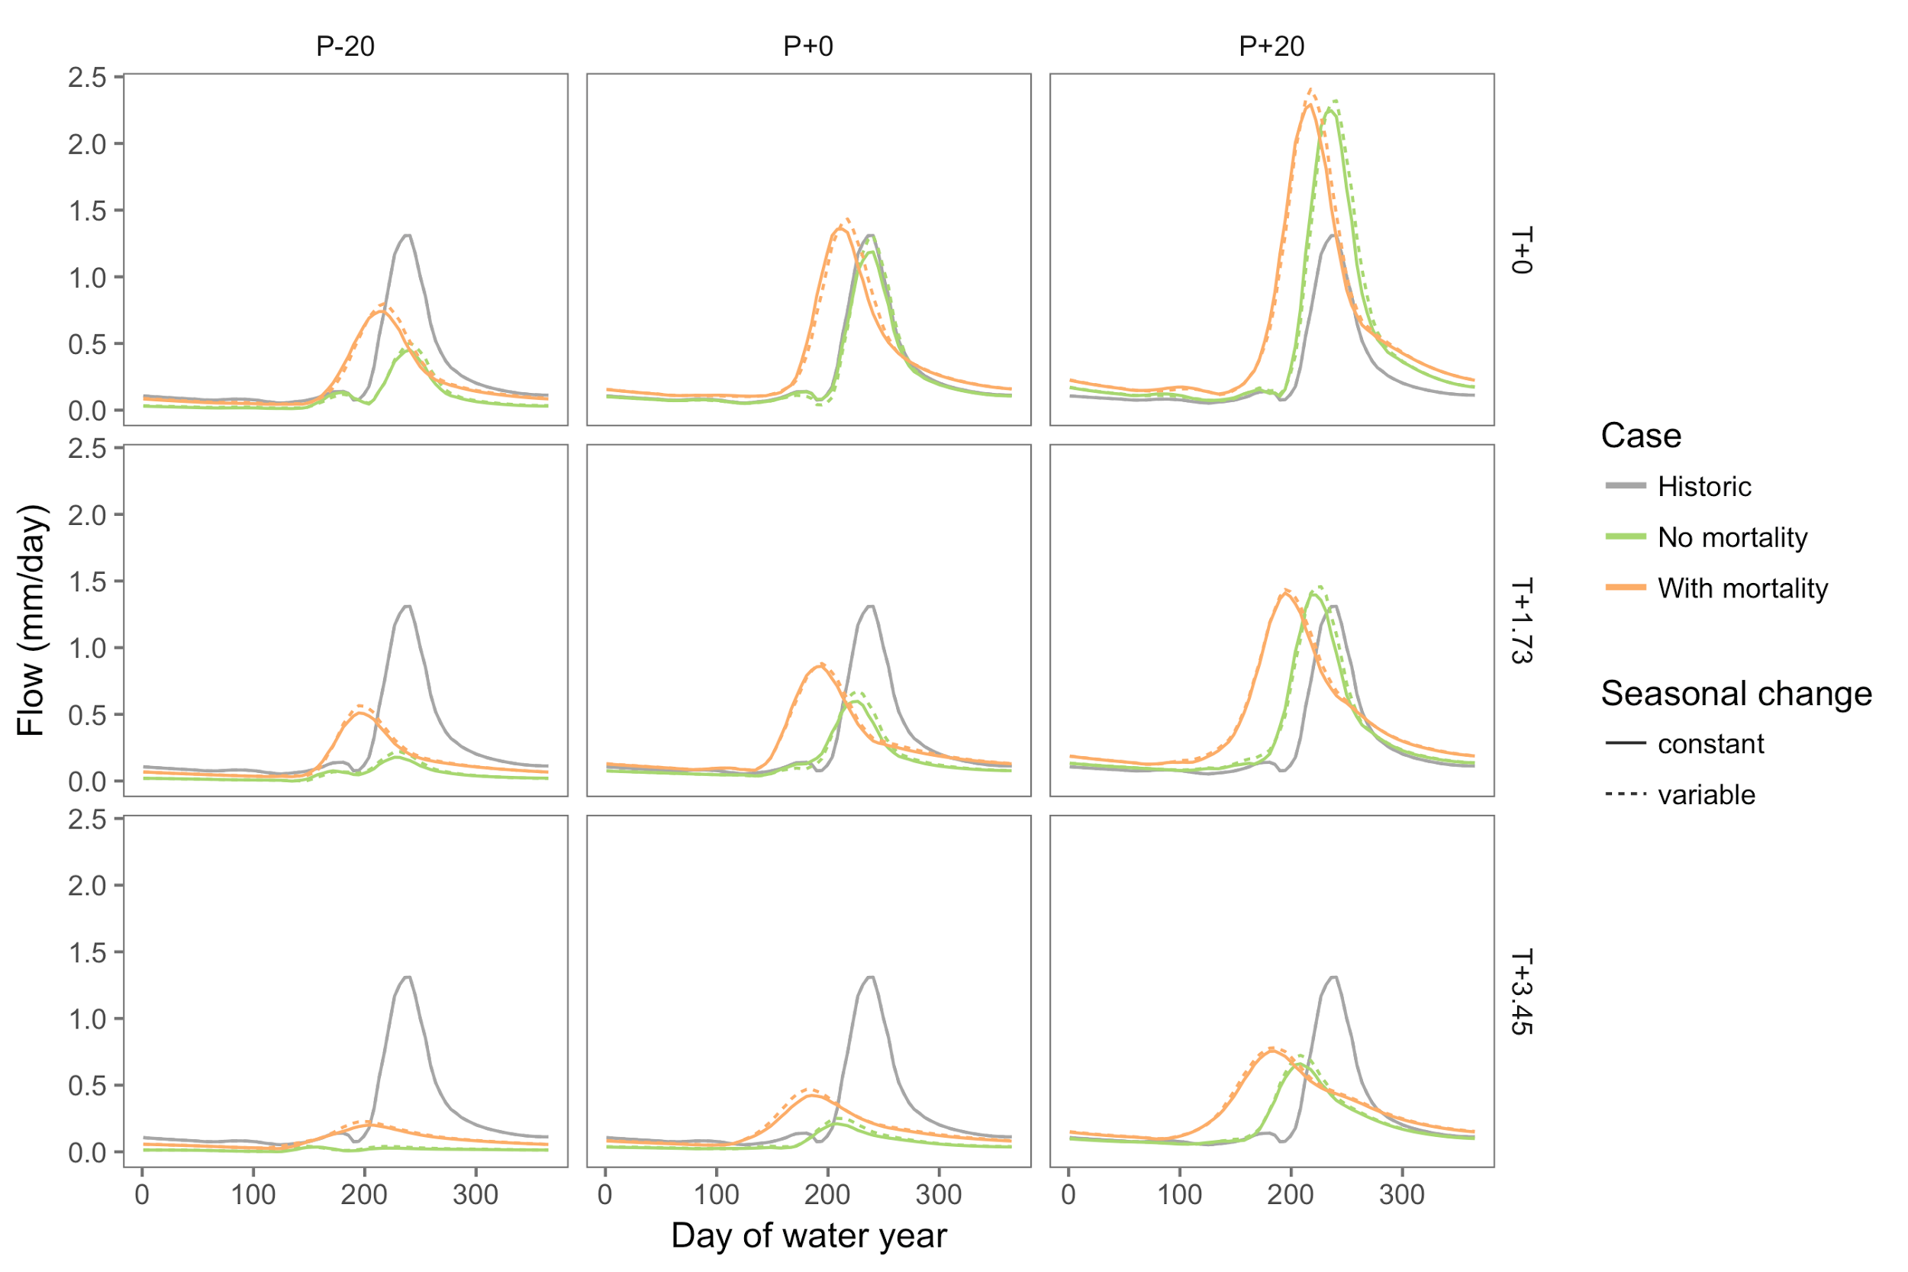

Figure 6.4.3. Area-weighted average flow in historic case, and under climate scenarios with and without aspen mortality. A subset of the full suite of scenarios is represented here for ease of interpretation. Each curve is a locally weighted regression with Gaussian weighting over a 3-month span, smoothing 30 years of data.

6.4.5 *Interannual variability*:

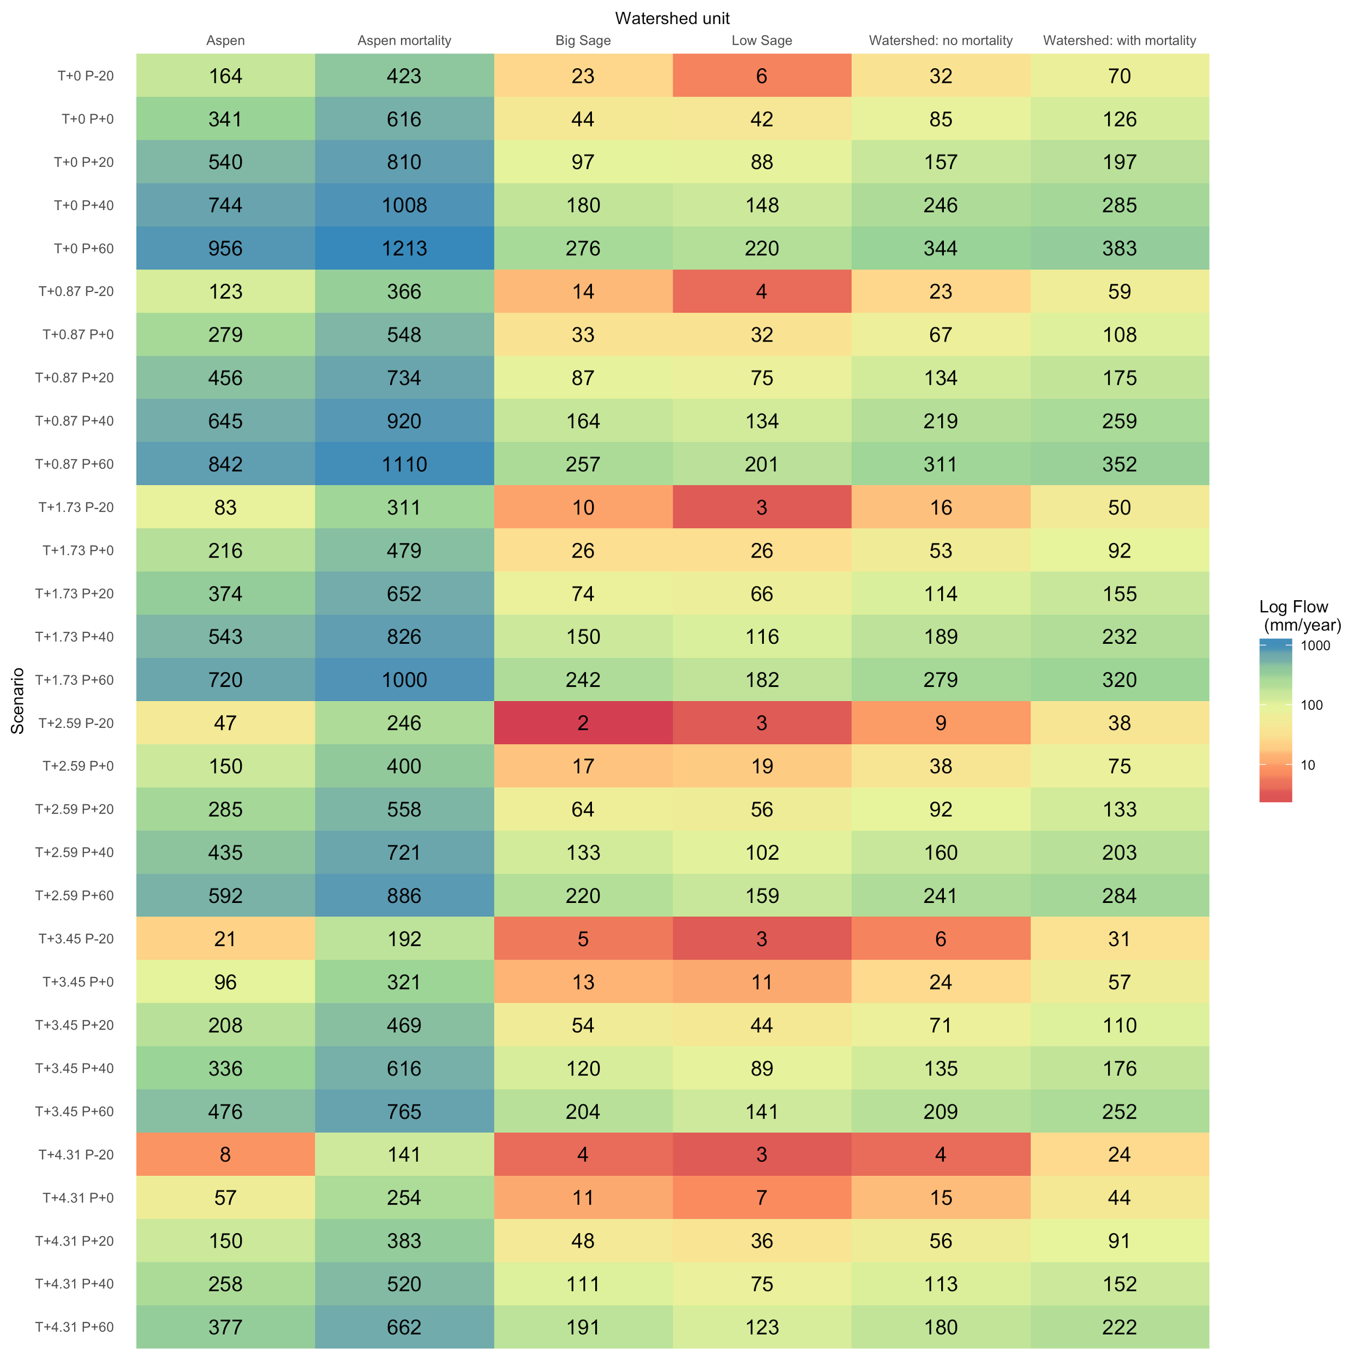

In the historic scenario, 46.7% of water years were energy-limited (Fig. 6.4.4). As temperatures increased, an increasing number of years became water-limited; with a temperature increase of 3.45 °C and no precipitation change, only 6.7% (2 out of 30) water years remained water-limited. This shift from energy-limited to water-limited hydrology was mitigated by increases in precipitation; the amount of precipitation increase needed to mitigate the shift increased with temperature. In scenarios with limited temperature increases and significant precipitation increase, water years generally moved downward through Budyko space, suggesting increased water availability for runoff. However, these are generally relatively unlikely scenarios.

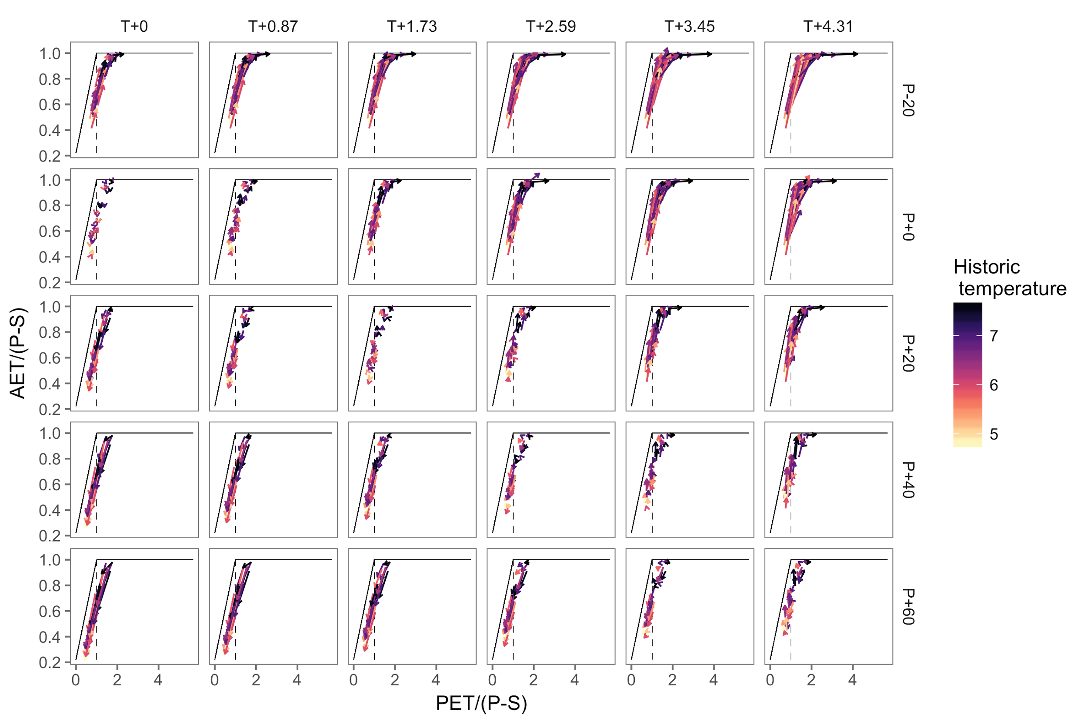

Fig. 6.4.4. Trajectories of each water year in the aspen HRU under multiple climate scenarios. Precipitation minus change in storage (P-S) is the available water; actual evapotranspiration (AET) and potential evapotranspiration (PET) are plotted as a fraction of this water availability.

**7. ANALYSIS AND FINDINGS**

**7.1 *Aspen productivity under shifting precipitation regimes***

Historically, aspen in the RCEW have remained productive across a wide range of meteorological conditions (Figure 6.1.5). By the mid-21st century, the capacity of both aspen to shift timing of growth and soils to store winter and spring precipitation will play an important role in the ability of these stands to maintain historical NPP rates during increasingly warm years with little to no drift formation. With warming, earlier canopy development and increased NPP during the spring can play a particularly important role in offsetting decreased productivity that occurs during the driest periods of the growing season. However, increasing sensitivity to evaporative demand and decreased NPP at mid-elevation sites suggest that the ideal range of aspen in the RCEW will experience contracting pressure as the climate becomes warmer and drier in the coming decades. Conversely, high elevation aspen stands may experience increased NPP as growing seasons become less temperature limited and higher total precipitation and lower evaporative demand buffer future drought severity.

These simulations provide insight into several ways upland aspen communities may function under a changing climate. When compared to historical simulations, we see that shifts in the timing of spring growth and productivity under climate change can partially counterbalance the impacts of an increasingly rain-dominated and uniform precipitation layer. These results indicate that the aspen’s deciduous leaf habit may play an increasingly important role in their ability to utilize soil moisture across expanding growing seasons while at the same time moderating their exposure to prolonged periods of stress through leaf senescence and dormancy in the fall.

**7.2 *Post fire aspen regeneration***

Our findings generally suggest that higher post-fire aspen density occurs when a greater portion of the post-fire precipitation occurs during winter months, and when pre-fire winter months are warmer than average. These two climate variables had among the largest effect sizes in our models (based on coefficients) and the latter was present and highly significant in all five of the best models. The role of warmer than average winter temperatures before fire is difficult to interpret, and may be linked more with climate conditions during antecedent years that encourage fire (e.g., causing drying of forest fuels, Westerling et al. 2006) than with any particular advantage for aspen regeneration. However, some research suggests that warmer winters can promote greater storage of carbohydrate reserves through increased photosynthetic activity (Foote and Schaedle 1976, 1978), thus potentially increasing post-fire regeneration potential. The influence of precipitation seasonality on post-fire aspen density is likely due to the timing of moisture availability relative to the ability of a surviving aspen clone to reproduce vegetatively (or for seedlings to successfully germinate). Aspen is not drought-tolerant (Lieffers et al. 2001) and relies on adequate soil moisture to remain productive throughout the growing season. Winter snowpack provides soil moisture subsidies that may be essential to aspen productivity and survival in semi-arid or seasonally-arid ecosystems (Oberbauer and Billings 1981, Seyfried et al. 2009). Moreover, if more of the post-fire precipitation arrives during winter than in the growing season, this could provide an advantage over herbaceous or shrub species that depend on growing season moisture availability; a dynamic that is also suggested by the negative relationship between aspen density and shrub cover in our final models. However, few studies have examined the effects of shrub competition on aspen regeneration in the western U.S. (e.g., Harvey et al. 2016). Our models also indicate that post-fire aspen density is positively correlated with higher heat loads, representing locations of higher incident solar radiation that generally have drier and warmer growing conditions. Other studies have found greater aspen regeneration on southerly slopes following fire (Turner et al. 2003, Harvey et al. 2016), potentially because these areas are less suitable to some conifer competitors. Finally, although the effect size is relatively weak in our model, we found that aspen density significantly increased following fire with more severely burned area around each plot, which corresponds to the results of several previous studies (Turner et al. 2003, Wan et al. 2014, Krasnow and Stephens 2015, Harvey et al. 2016). Aspen are a fire-adapted species, and their ability to re-sprout following fire gives them a competitive advantage over other species. Specifically, severe fire decreases inter-specific competition by killing other trees, shrubs, and herbaceous vegetation, and also by increasing light availability, thereby creating a favorable environment for aspen sucker growth following fire.

*7.3 Forecast aspen distributions*

Our results indicate that under future climate scenarios, occasional establishment can create aspen patches that persist for long periods within or next to snowbanks. This trend is climate-specific however; aspen regeneration becomes more infrequent under the high emissions climate scenarios, while climate-related mortality events increase, resulting in lower overall area occupied by aspen. In general, a long-term biomass decline is evident, dictated by the balance between regeneration and mortality. This balance is particularly important for sites within or adjacent to our modeled snowbanks. Though neither establishment nor mortality are always highest in the snowbanks, the relative balance between these two factors results in more long term persistence on sites in or near the snowbanks. Mortality within these sites is a combination of climate-induced stress as well as age-related senescence, but infrequent establishment events are sufficient to keep aspen on many sites for the duration of the simulations. This pattern is seen most evidently in the central eastern portion of the study area, where even in high emissions climate, aspen stands are resilient to the extirpation seen in more southerly sites.

In addition, our simulations indicate an expansion of Douglas fir in the southeast corner of the landscape. This conifer encroachment reduces the area of aspen as aspen cannot regenerate in the shade created by a Douglas fir overstory. Overall, our model indicates a decline of aspen across the study area although aspen declines slowest in the east-central area. This area is expected to maintain snowbanks to some degree while experiencing the least additional competition from Douglas fir. Our two climate scenarios differ primarily in degree whereby the RCP4.5 (low emissions) maintained the most aspen biomass (although declining) and the largest aspen area (also declining).

**7.4 *Hydrological Regime Changes***

Temperature increases within the range of future climate projections in a business-as-usual scenario decrease SWEmax in drift-subsidized aspen stands by 74.3% on average across water years. SWEmax in this environment is sensitive to both temperature and precipitation, so increases or decreases in precipitation can exacerbate or mitigate these reductions in SWEmax. Accounting for the projected seasonal variability of changes in temperature very slightly mitigates reductions in SWEmax, but this source of variability is small compared to projected magnitudes of temperature and precipitation change.

One possible result of climate change is aspen mortality. In a scenario where aspen patches are replaced by grass cover, aspen mortality exacerbates the seasonal shift in timing of runoff (Fig. 6.4.3). However, aspen mortality, mitigates the projected reduction in volume of runoff in scenarios, especially in cases where the combined temperature and precipitation changes reduce overall volume as shown by comparing the “Aspen” and “Aspen mortality” columns in Table 6.4.1, especially for cases with the greatest temperature increases and precipitation declines.

Analysis of interannual trajectories in Budyko space revealed a shift from a system in which water years varied between energy- and water-limitation to one that was more frequently water-limited as temperatures increased. However, this shift was somewhat mitigated by increases in precipitation.

**8. CONCLUSIONS AND RECOMMENDATIONS**

The findings of this project are important for managing aspen in light of future projected climate and fire regime changes across the western United States. Under projected climate change, fire activity is generally expected to increase (XXXX, XXXX) and warming temperatures and changes in precipitation patterns, including drought, could potentially result in substantial changes in forest communities and aspen cover over time (Dobrowski et al. 2015, Rehfeldt et al. 2009). These changes have ramifications for forest ecology and management in the central/northern Rockies and northern Great Basin ecoregions. Our research was able to more specifically address key relationships and dynamics in the region that will help us to better understand the mechanisms that could lead to future aspen decline.

While no significant changes in the amount of total precipitation have been documented within the RCEW (Nayak et al. 2010, Seyfried et al. 2011), precipitation in the watershed is becoming increasingly rain-dominated at all elevations. Future shifts in the timing and phase of precipitation could impact aspen communities depending on their location along this shifting precipitation phase gradient. The results presented here (for Objective 1) indicate that historically, the redistribution of precipitation is particularly important at drier sites that both receive 500 mm or less annual precipitation and have high soil moisture storage capacity. However, as temperatures and drought severity increase, so will the vulnerability of many semi-arid and forest ecosystems. By the mid-21st century, mid-elevation sites in this study are projected to experience reduced NPP via increasing evaporative demand and drought severity. However, our simulations also suggest that aspen stands have some capacity to shift periods of growth and remain productive under significant temperature and precipitation changes. This is probably because, although temperature directly influences both the precipitation phase and intensity of evaporative demand, plants can utilize numerous strategies to adjust and moderate their function in the face of severe drought.

The role of climate variability in the influencing aspen regeneration after fire is also an important consideration given expected climate change effects. Numerous recent studies have documented how the potential for forest recovery after fire may be altered under extreme climate conditions (Harvey et al 2016, Dodson and Root 2013). However, some studies suggest that more fire could be beneficial to aspen under some future climate conditions (Yang et al. 2015). Although our results (Objective 2) don’t indicate a general lack of successful aspen regeneration after fire in the central/northern Rockies in recent decades, they do underscore that key climate drivers of successful aspen regeneration could be at risk under changing future climates. In particular, the loss of winter season precipitation could be detrimental to regeneration potential of aspen, based on both the results from Objective 1 (XXXX) and Objective 2 (Table 6.2).

We were successful in addressing Objective 2 and all tasks were completed as outlined in the original proposal, with the exception of problems with permits outlined in section 4.2. If we were to conduct this project again, we would collect tree age and soil data at each plot. With age data, we could have examined the impact of annual climate variability on tree establishment and also explored climate relationships to annual tree growth rates and productivity. Soils data would have allowed us to examine site-specific moisture availability, contributing an additional suite of variables to our analyses. Future work will likely involve collecting these data to address the impact of climate and site conditions on post-fire aspen stand dynamics. We may also return to sites sampled in this project, which would allow investigation of how the impacts of climate and environment on aspen regeneration might change over time.

We were successful in addressing Objective 2 and all tasks were completed as outlined in the original proposal, with the exception of ….[explanation of what didn’t work coming]

With respect to landscape fire regimes in a changing climate, for the purposes of the study to this point we only implemented a ‘current day’ fire regime, defined by fire rotation period and fire size distributions of the surrounding area. Though we intend to update subsequent LANDIS-II simulations to reflect a more extreme fire future, there is a high degree of uncertainty when applying a landscape-scale fire regime to such a small study extent.

8.4 Hydrological Effects

Recommendations

Future directions

* Refine aspen vulnerability map, scale up hydro analysis
* Hydro: Extend snow classification to: a. Hydrological regime classification, and b. Regime class delta for climate change, c. Regime class delta for vegetation change coupled with CC
* Outreach once final papers are published – research briefs and webinar
* …?

**9. MANAGEMENT APPLICATIONS AND PRODUCTS**

To complete this aspect of the project, we collaborated with managers across several U.S. National Forests, U.S. Bureau of Land Management, and Natural Resources Conservation Service districts, as well as non-governmental organizations. With each manager that we worked with, we provided the project proposal and initiated discussions about how our project could be designed within the context of the funded proposal to produce results that would best benefit management objectives. Table 9.1 provides an overview of the key managers that we worked with, although the list of collaborators is much higher when including additional people that were apprised of, and contributed to this project. We will send our final report to all stakeholders we worked with during this project.



|  |  |  |
| --- | --- | --- |
| Table 9.1**:**  Primary collaborators, location, and agency/affiliation | | |
| **Manager/Contact** | **State** | **Land Management Agency** |
| Jeff Alexander | Idaho | Boise National Forest |
| Kathy Nash | Idaho | Payette National Forest |
| Gail Baer | Idaho | Salmon Challis National Forest |
| Jill Algood | Idaho | Sawtooth National Forest |
| Joe Adamski | Idaho | Idaho Bureau of Land Management |
| Jason Wright | Idaho | Bureau of Land Management-Idaho Falls District |
| Elena Shaw | Idaho | Bureau of Land Management-Twin Falls District |
| Sarah Garcia | Idaho | Bureau of Land Management - Boise |
| Anne Halford | Idaho | Bureau of Land Management - Boise |
| Kaye Olpin | Idaho/Wyoming | Caribou Targhee National Forest |
| Patty Bates | Montana | Beaverhead Deerlodge National Forest |
| Marilyn Wildey | Montana | Bitterroot National Forest |
| Liz McFarland | Montana | Gallatin National Forest |
| Frank Cifala | Montana | Gallatin National Forest |
| Zev Hunting | Montana | Helena National Forest |
| Jared Bybee | Montana | Montana Bureau of Land Management |
| Pat Fosee | Montana | Montana Bureau of Land Management |
| MaryLou Zimmerman | Montana | Montana Bureau of Land Management |
| Stacia Kimball | Oregon | Malheur National Forest |
| Jeff Bloom | Oregon | Umatilla National Forest |
| Patti Beeks | Oregon | Wallowa Whitman National Forest |
| Diane Shirley | Oregon | Umatilla National Forest |
| Ed Farren | Oregon | Umatilla National Forest |
| Robert Taylor | Oregon | The Nature Conservancy |
| Aaron Roth | Oregon | Natural Resources Conservation Service |
| Paul Rogers | Utah | Western Aspen Alliance |
| Travis Bruch | Wyoming | Bridger Teton National Forest |

Discussions with managers revealed that a variety of active management practices (e.g. fencing to reduce browsing) are being used in region to promote the establishment and vitality of isolated aspen stands. A key management concern is whether specific locations where active management is being considered will be able to support aspen stands under future climate regimes. A secondary concern in some areas where surface water is used for small-scale irrigation is how hydrological flows will be affected by climate and land cover changes. A consistent message from managers is that they do not have the time to carefully read scholarly publications to glean the management implications. They have therefore advised the project team that in addition to peer-refereed publications, preparation of research briefs detailing potential management applications of research findings is a critical need. Where spatial data is produced as part of a research project, easy data access using freely available tools was also noted as a critical need.

There are a number of management concerns that can be improved upon based on the new understanding and models developed as part of this research. For example, results from the regional model of the mechanisms impacting post-fire aspen regeneration can be used by managers in several ways. Understanding how aspen respond following fire will provide managers a more comprehensive understanding of how projected future changes may impact aspen conservation and persistence. Additionally, managers can use our findings in planning for prescribed burns or managing wildfires.

Results from the finer-scale biophysical process modeling of aspen sensitivity to climate change within the Reynolds Creek Experimental Watershed (RCEW) can be used to gain insight into how stands in other areas are likely to respond to climate changes when placed in the context of regional snow regimes. For this research, RCEW served as a natural laboratory to advance the fundamental understanding of how drift-dependent aspen stands are affected by historical and projected future climate regimes because it spans a range of topoclimates that characterize a large portion of mid-elevations throughout the interior Pacific Northwest. General insight for how drift-dependent aspen stands will be affected by climate changes and hence how to prioritize active management tactics can be provided by determining the snow regime where specific aspen stands are located. Snow regimes can be broadly classified as cold, cool, warm, and ephemeral based on snowpack dynamics, and as high, moderate, and low temporal stability, based on interannual variations in snow regime. For example, a high stability location would typically be characterized by the same regime across many years, whereas low stability locations are characterized by regimes that vary dramatically between years. Snow regimes are important for drift-dependent aspen patches because drifts can augment water available to support late-season transpiration especially in cool snow regimes where mid-winter melt events can deplete large amounts of upland snow storage, whereas localized storage in drift deposition zones may be retained.

Locations of aspen stands (LANDFIRE, 2014) overlain on a new 1 km2 snowpack classification data product (SnowClusters; Tennant et al. in prep.) defined by general temperature regime and temporal stability are presented in Fig. 9.1. The combined data products indicate that the most spatially extensive aspen stands occur within cold snow regimes, but that many dispersed small stands comprising approximately 15% of areas with aspen (Table 9.2) occur in cool snow regimes many of which are dependent on isolated snow drifts (e.g. RCEW in SW ID, Zumwalt Prairie in NE OR). The simulations at RCEW suggest that aspen stands in the cool, moderate stability snow regimes are less sensitive to climatic warming, whereas stands that are much closer to the boundary of the warm snow regimes are likely to experience declines in NPP due to losses of drift subsidies and increased midsummer evaporative demand. Likewise, the simulation results forecasting future aspen distributions indicate that less frequent establishment of aspen stands in likely to occur near zones, and especially near the cool, low stability and warm snow regimes that are most susceptible to losses of drift moisture subsidies.

Resilience or susceptibility of specific aspen stands to climate changes depend on other site-specific factors such as access to shallow groundwater and soil moisture storage characteristics, however the location of stands relative to snow classes can provide important insight for managers about the potential viability of drift-dependent stands in future climates based on project results. When combined with local knowledge, the research findings coupled with the new snow regime data product can help managers prioritize stand treatments at the most viable locations to maximize potential ecological benefits from the investment of resources. The data displayed in Fig. 9.1 will be provided as a KMZ file so that managers can easily use Google Earth to identify where an aspen stand of interest is located relative to specific snow classes. The 1 km spatial resolution (Fig 9.1b) of the data product is at a sufficiently fine scale for managers to gain insight into both the relative vulnerability of a given stand, and potential for general hydrologic changes with or without mortality under future climate conditions. Specific hydrological changes will be highly site and scale-dependent, however the general results of the hydrological analysis (Table 6.4.1) will assist small-scale water users in adapting climate changes by emphasizing the need to reduce demand or develop new supplies for warmer years without precipitation increases, unless changes are accompanied by extensive vegetation mortality resulting in decreased evaporation and transpiration losses.

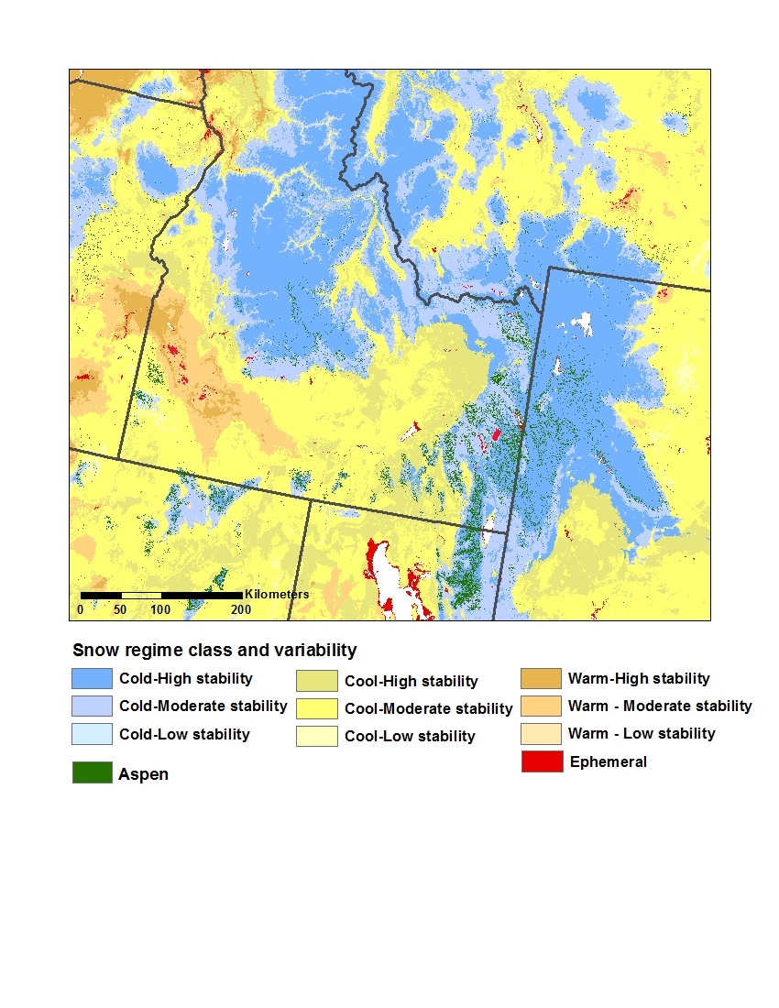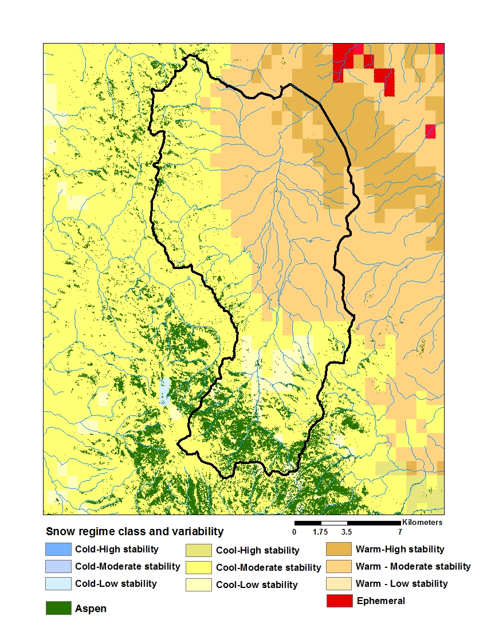

Figure 9.1. a.) Aspen areas overlayed with a combination of snow regime class (cold, cool, warm, and ephemeral) and temporal stability (high, moderate, low). b.) Detail of the Reynolds Creek Experimental Watershed with aspen stand locations and snow regime classes.

Table 9.2. Area of aspen in different snow regime and stability classes within the study area.



**10. OUTREACH**

Publications

Flerchinger, G. N., Reba, M. L., Link, T. E., and Marks, D. 2015. Modeling temperature and humidity profiles within forest canopies. *Agricultural and Forest Meteorology*, *213*, 251-262. doi:10.1016/j.agrformet.2015.07.007

Harpold, A. A., Kaplan, M. L., Klos, P. Z., Link, T., McNamara, J. P., Rajagopal, S., Schumer, R., and Steele, C. M.: Rain or snow: hydrologic processes, observations, prediction, and research needs, Hydrol. Earth Syst. Sci., 21, 1-22, doi:10.5194/hess-21-1-2017, 2017.

Marshall, A., Link T., G. Flerchinger, and L. Tedrow. 2017. Sensitivity of snow and hydrological dynamics to climate and vegetation changes in a catchment characterized by wind-driven redistribution of snow. To be submitted to Ecohydrology. June 2017.

Shinneman, D.J and S.K. McIlroy. Effects of climate and environmental setting on post-fire aspen regeneration across the central and northern Rocky Mountains (USA). To be submitted to Forest Ecology and Management, June 2017.

Soderquist, B., Kavanagh, K., Link, T., Seyfried, M. Simulating the dependence of aspen (*Populus tremuloides*) on redistributed snow in a semi-arid watershed. *To be submitted to Ecological Applications, May 2017.*

Soderquist, B., Kavanagh, K., Link, T., Seyfried, M., Strand., E. Growing season conditions mediate the dependence of aspen on redistributed snow under climate change. *To be submitted to Global Change Biology, June 2017.*

Soderquist, B., Kavanagh, K., Strand., E., Link, T., Seyfried, M. Warming temperatures and reductions in redistributed snow differentially impact the simulated productivity of sagebrush steppe vegetation. *To be submitted to Rangeland Ecology and Management, July 2017.*

Tennant, C., S. Godsey, A. Harpold, L. Larsen, T. E. Link, and S. Rajagopal. (in preparation). A novel classification system to capture mountain snowpack spatiotemporal heterogeneity. To be submitted to: Geophysical Research Letters. *July 2017*.

Workshops and Educational Outreach

Workshop: “The vulnerability of aspen in a world with declining snow cover” held in Boise, ID on April 22, 2015.  The workshop was attended by 22 scientists and managers.

Stakeholder and Educational Outreach

Link, T. and project team. “Recent advances and ongoing research on the ecohydrological dynamics of: Western junipers, aspen patches, and forest snow in complex terrain”. NRCS Snake River and John Day/Umatilla Basin Team Meeting. October 28, 2015. ~50 attendees.

Soderquist, B. and C. Rushlow. *Snow and Water Resources: Idaho’s Changing Climate*

* Summer, 2016. Boise EPSCoR Adventure Learning Workshop. Boise, ID.
* Spring 2016. Confluence project training for educators and graduate students. McCall, ID.
* Winter 2016. University of Idaho Environmental Law Club. McCall, ID

Soderquist, B. and C. Rushlow. *Climate and our Changing Seasons*. Spring 2016. Community speaker series, Boise Foothills Learning Center. Boise, ID.

Soderquist, B. *Climate Change in Idaho*. K-12 outreach lectures at local schools throughout 2016.

Strand, E. and project team. “Impacts of Earlier Snowmelt on Aspen Woodlands” Rangeland Center Forum Field Tour, Reynolds Creek, ID, Oct 21, 2016. ~50 participants.

Presentations

Godsey, S., C. Tennant, A. A. Harpold, T. E. Link, S. Rajagopal, and L. Larsen. Do existing classification systems capture mountain snowpack heterogeneity? Accounting for spatial variability in a changing environment. Abstract C13F-05. Presented at 2016 Fall Meeting, AGU, San Francisco, Calif., 12-16 Dec, 2016.

Marshall, A., T. E. Link, G. Flerchinger, and L. Tedrow. 2017. Sensitivity of snow and hydrological dynamics to climate in a catchment characterized by wind-driven redistribution of snow. Western Snow Conference, Boise, ID, April 17-20, 2017. *Oral presentation*

Soderquist, B., Kavanagh, K., Link, T., Strand, E., Seyfried, M. 2016. Growing season conditions mediate the dependence of aspen on redistributed snow under climate change. American Geophysical Union annual meeting, December 12-16. *Poster* *presentation.*

Soderquist, B., Kavanagh, K., Link, T., Seyfried, M., Strand, E. 2015. Projecting the Dependence of Sagebrush Steppe Vegetation on Redistributed Snow in a Warming Climate. American Geophysical Union annual meeting, December 14-18. *Oral* *presentation*

Soderquist, B., Kavanagh, K., Link, T., Seyfried, M., Niemeyer, R., Strand, E. 2015. Projecting the dependence of aspen productivity on redistributed snow in a warming climate. Pacific Northwest Climate Conference. November 4-5. *Oral presentation*.

Soderquist, B., Kavanagh, K., Link, T., Seyfried, M., Strand, E. 2014. Simulating the Dependence of Sagebrush Steppe Vegetation on Redistributed Snow in a Semi-Arid Watershed. American Geophysical Union annual meeting, December 15-19. *Oral* *presentation*

Soderquist, B., Kavanagh, K., Link, T., Seyfried, M. 2014. Simulating the dependence of aspen net primary productivity on redistributed snow in a semi-arid watershed. International Union of Forest Research Organizations World Congress, October 6-10. *Poster* *presentation.*

Soderquist, B., Kavanagh, K., Link, T., Seyfried, M. 2013. Simulating the dependence of aspen net primary productivity on redistributed snow. American Geophysical Union annual meeting, December 9-13. *Poster presentation.*

**LITERATURE CITED [Susan is formatting and checking references]**